**Maverick Bank - Output Report**

Name: Yash Sudhakar Jadhav

Superset ID: 5298089

College: Imperial College of Engineering and Research, Pune

Email: yashj98819@example.com

Date & Time: July 17, 2025 - 05:00 PM

**Index** –

**Maverick Bank frontend - page 2**

**Maverick Bank Backend - Page 45**

 Maverick Bank Frontend

A modern, feature-rich Angular-based frontend application for comprehensive banking operations. This application provides a complete digital banking solution with role-based access for customers, employees, and administrators.

## 📋 Project Description

Maverick Bank Frontend is a sophisticated web application that serves as the user interface for a full-stack banking system. It offers secure account management, loan processing, money transfers, transaction monitoring, and comprehensive reporting capabilities. The application is built with Angular 20 and follows modern web development practices with a focus on security, usability, and responsive design.

## 🛠️ Tech Stack Used

### Frontend Framework & Core

* Angular 20.0.0 - Modern TypeScript-based framework
* TypeScript 5.8.2 - Type-safe programming language
* RxJS 7.8.0 - Reactive programming with observables
* Zone.js 0.15.0 - Change detection and async operations

### UI & Styling

* Custom CSS - Modern, responsive design system
* Google Fonts (Inter) - Typography
* CSS Grid & Flexbox - Layout systems
* CSS Variables - Theme management
* Responsive Design - Mobile-first approach

### Development & Testing

* Angular CLI 20.0.5 - Project tooling and build system
* Jasmine 5.7.0 - Testing framework
* Karma 6.4.0 - Test runner
* TypeScript Compiler - Code compilation

### Build & Deployment

* Angular Build System - Optimized production builds
* Proxy Configuration - Development API routing
* Environment Configuration - Multi-environment support

## 🏗️ Folder Structure

maverick-bank-frontend/  
├── src/  
│ ├── app/  
│ │ ├── components/ # All Angular UI components  
│ │ │ ├── home/ # Landing page component  
│ │ │ ├── login/ # User authentication  
│ │ │ ├── register/ # New user registration  
│ │ │ ├── dashboard/ # Role-based main dashboard  
│ │ │ ├── account-management/ # Account operations & details  
│ │ │ ├── account-approval/ # Employee account approval  
│ │ │ ├── customer-account-request/ # New account requests  
│ │ │ ├── employee-account-management/ # Employee account tools  
│ │ │ ├── loan-management/ # Loan applications & management  
│ │ │ ├── loan-type-management/ # Admin loan type configuration  
│ │ │ ├── money-transfer/ # Fund transfer operations  
│ │ │ ├── transactions/ # Transaction history & details  
│ │ │ ├── beneficiaries/ # Payee management  
│ │ │ ├── customer-reports/ # Customer reporting tools  
│ │ │ ├── customer-reports-page/ # Customer report dashboard  
│ │ │ ├── employee-reports/ # Employee reporting tools  
│ │ │ ├── employee-reports-page/ # Employee report dashboard  
│ │ │ ├── user-management/ # Admin user management  
│ │ │ └── notifications/ # Global notification system  
│ │ ├── services/ # API communication & business logic  
│ │ │ ├── auth.service.ts # Authentication & JWT management  
│ │ │ ├── account-management.service.ts # Account operations  
│ │ │ ├── account-request.service.ts # Account request handling  
│ │ │ ├── loan.service.ts # Loan operations  
│ │ │ ├── loan-type.service.ts # Loan type management  
│ │ │ ├── money-transfer.service.ts # Transfer operations  
│ │ │ ├── transaction.service.ts # Transaction handling  
│ │ │ ├── beneficiary.service.ts # Beneficiary management  
│ │ │ ├── report.service.ts # Report generation  
│ │ │ ├── user-management.service.ts # User operations  
│ │ │ ├── notification.service.ts # Notification system  
│ │ │ ├── loading.service.ts # Loading state management  
│ │ │ ├── navigation.service.ts # Navigation utilities  
│ │ │ └── bank.service.ts # Bank-specific operations  
│ │ ├── guards/ # Route protection  
│ │ │ ├── auth.guard.ts # Authentication verification  
│ │ │ └── role.guard.ts # Role-based access control  
│ │ ├── interceptors/ # HTTP request/response handling  
│ │ │ ├── auth.interceptor.ts # JWT token attachment  
│ │ │ └── error.interceptor.ts # Global error handling  
│ │ ├── shared/ # Shared utilities & resources  
│ │ │ └── logo.ts # Logo management  
│ │ ├── app-routing-module.ts # Application routing configuration  
│ │ ├── app-module.ts # Main application module  
│ │ └── app.ts # Root component  
│ ├── assets/ # Static resources  
│ │ └── images/ # Image assets  
│ │ └── maverick-logo.png # Application logo  
│ ├── styles.css # Global application styles  
│ ├── index.html # Application entry point  
│ └── main.ts # Application bootstrap  
├── public/ # Public static files  
│ ├── favicon.ico # Browser favicon  
│ └── images/ # Public images  
├── proxy.conf.json # Development proxy configuration  
├── angular.json # Angular workspace configuration  
├── package.json # Dependencies & scripts  
├── tsconfig.json # TypeScript configuration  
└── README.md # Project documentation

## 🧩 Component Breakdown

### Core Components

#### 1. Home Component (/home)

* Purpose: Landing page with modern design and navigation
* Features:   
    
  Professional banking-themed hero section  
  Feature highlights and service overview  
  Call-to-action buttons for registration/login  
  Responsive navigation with animated elements
* Professional banking-themed hero section
* Feature highlights and service overview
* Call-to-action buttons for registration/login
* Responsive navigation with animated elements
* Connected Services: NavigationService
* Key Functionality: User onboarding and initial engagement

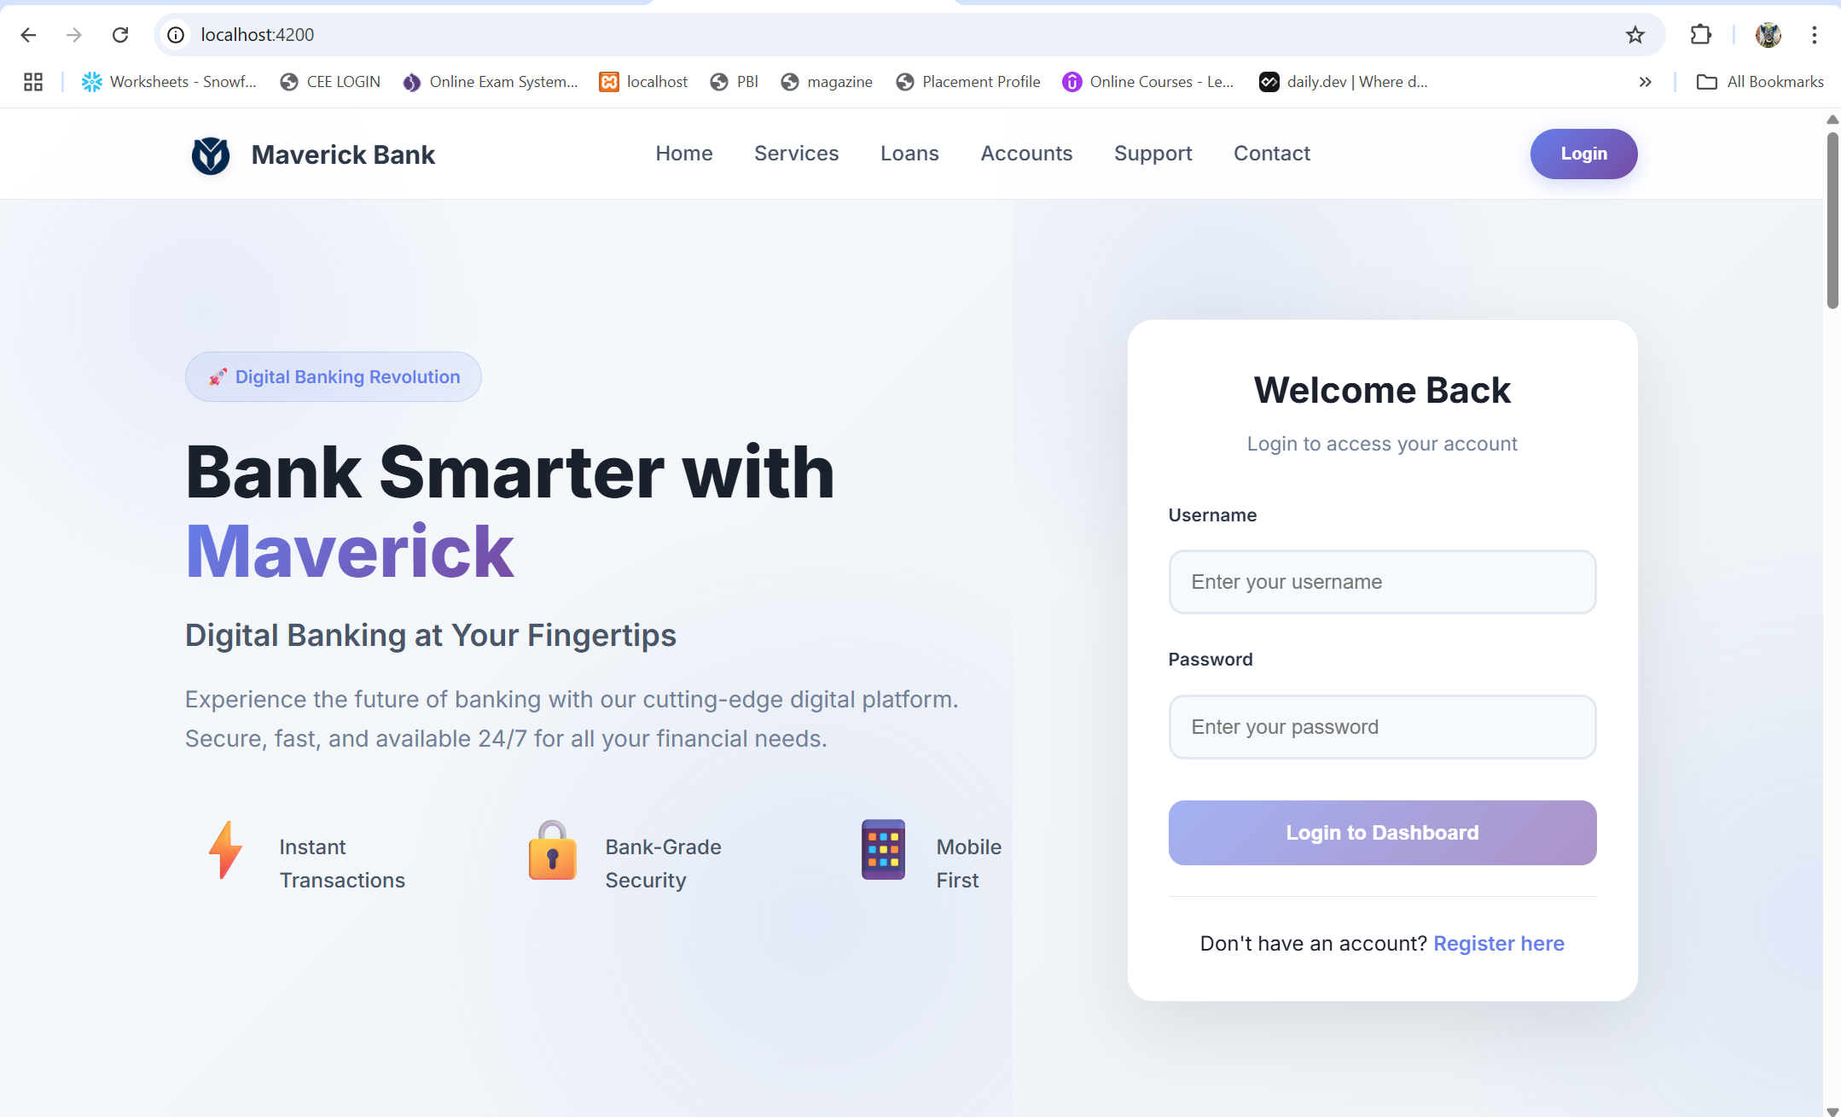

#### 2. Login Component (/login)

* Purpose: Secure user authentication
* Features:  
    
  JWT-based authentication with form validation  
  Role-based redirect after successful login  
  Error handling with user-friendly messages  
  Remember me functionality
* JWT-based authentication with form validation
* Role-based redirect after successful login
* Error handling with user-friendly messages
* Remember me functionality
* Connected Services: AuthService, NotificationService
* Security: Token management, input sanitization

#### 3. Register Component (/register)

* Purpose: New user registration with comprehensive data collection
* Features:  
    
  Multi-step form with validation  
  Real-time field validation  
  Secure password requirements  
  Identity verification fields (Aadhar, PAN)
* Multi-step form with validation
* Real-time field validation
* Secure password requirements
* Identity verification fields (Aadhar, PAN)
* Connected Services: AuthService, NotificationService
* Validation: Email format, phone number, government ID validation

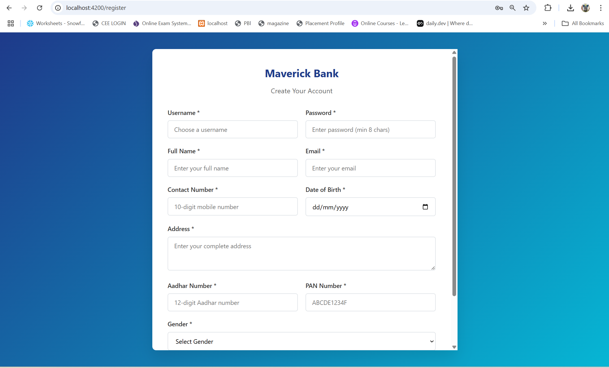

#### 4. Dashboard Component (/dashboard)

* Purpose: Role-based main interface after login
* Features:  
    
  Customer Dashboard: Account overview, recent transactions, quick actions  
  Employee Dashboard: Pending approvals, customer management tools  
  Admin Dashboard: System overview, user management, reports  
  Dynamic content based on user role  
  Modern card-based layout with statistics
* Customer Dashboard: Account overview, recent transactions, quick actions
* Employee Dashboard: Pending approvals, customer management tools
* Admin Dashboard: System overview, user management, reports
* Dynamic content based on user role
* Modern card-based layout with statistics
* Connected Services: AuthService, AccountManagementService, NavigationService
* Key Functionality: Central hub for all banking operations

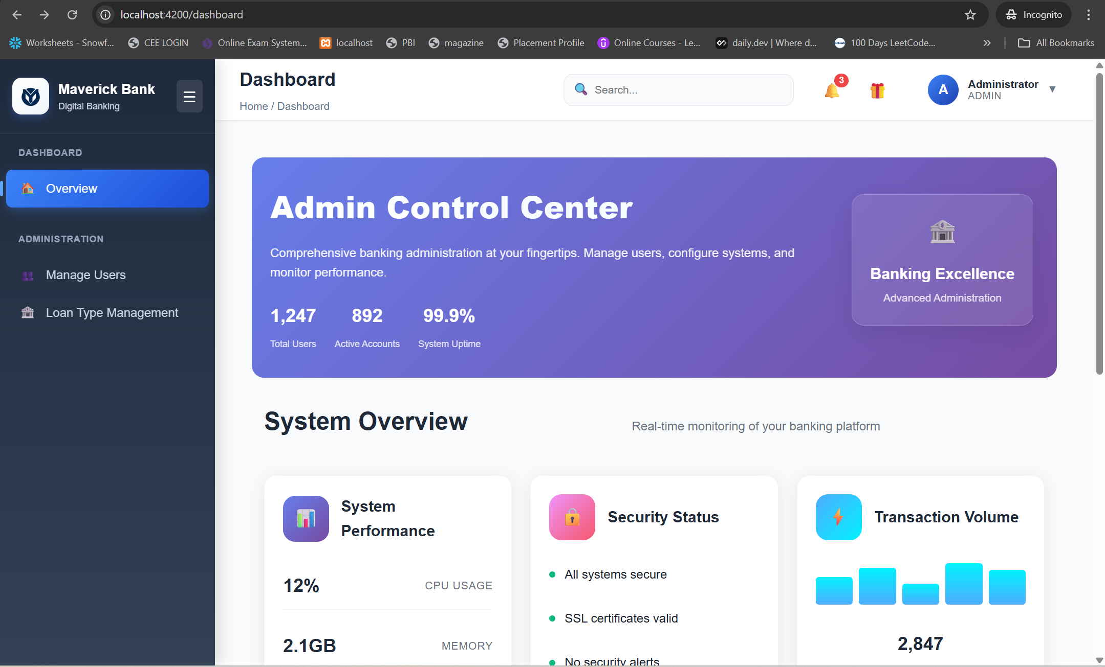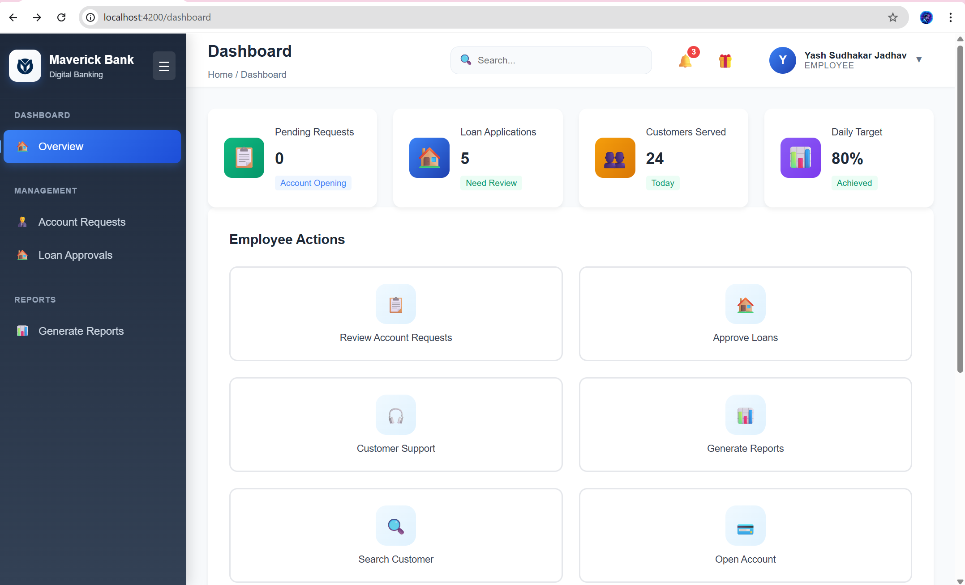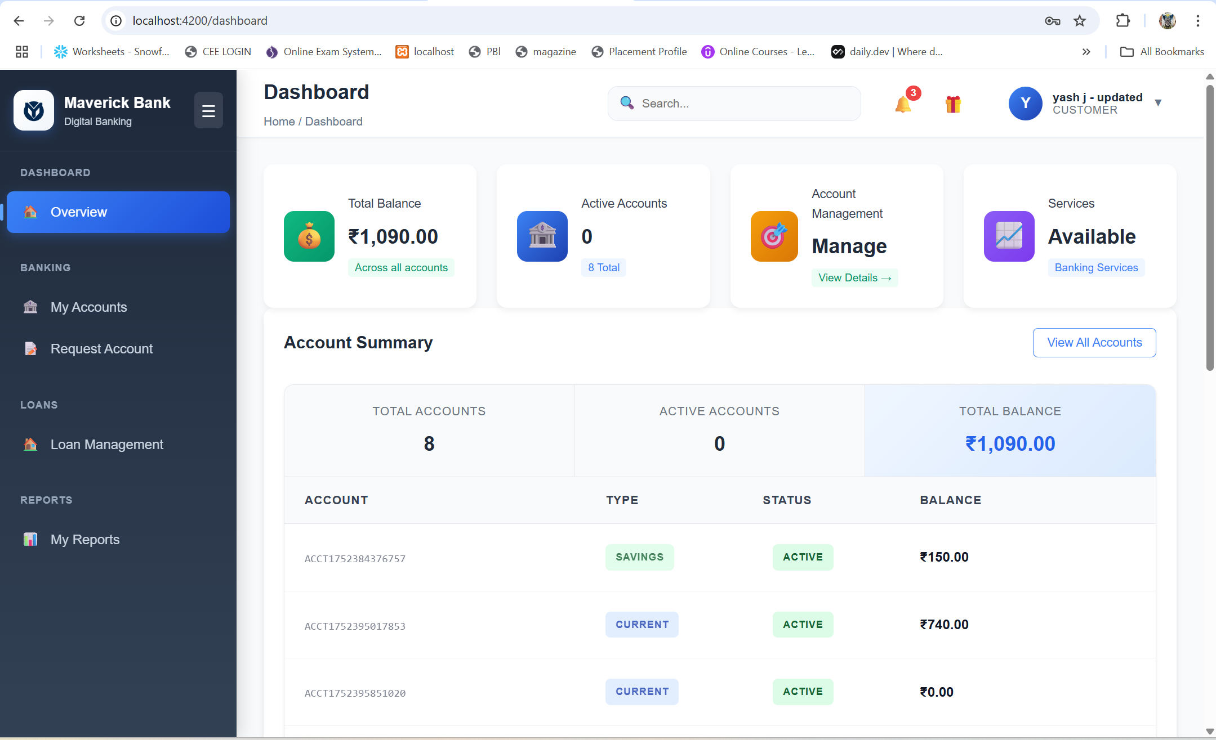

### Account Management Components

#### 5. Account Management Component (/accounts)

* Purpose: Comprehensive account operations and viewing
* Features:  
    
  Multi-tab interface (Account Details, Transactions, Statements)  
  Real-time balance updates  
  Transaction filtering and search  
  Account status management  
  Downloadable statements
* Multi-tab interface (Account Details, Transactions, Statements)
* Real-time balance updates
* Transaction filtering and search
* Account status management
* Downloadable statements
* Connected Services: AccountManagementService, TransactionService
* Key Functionality: Complete account lifecycle management

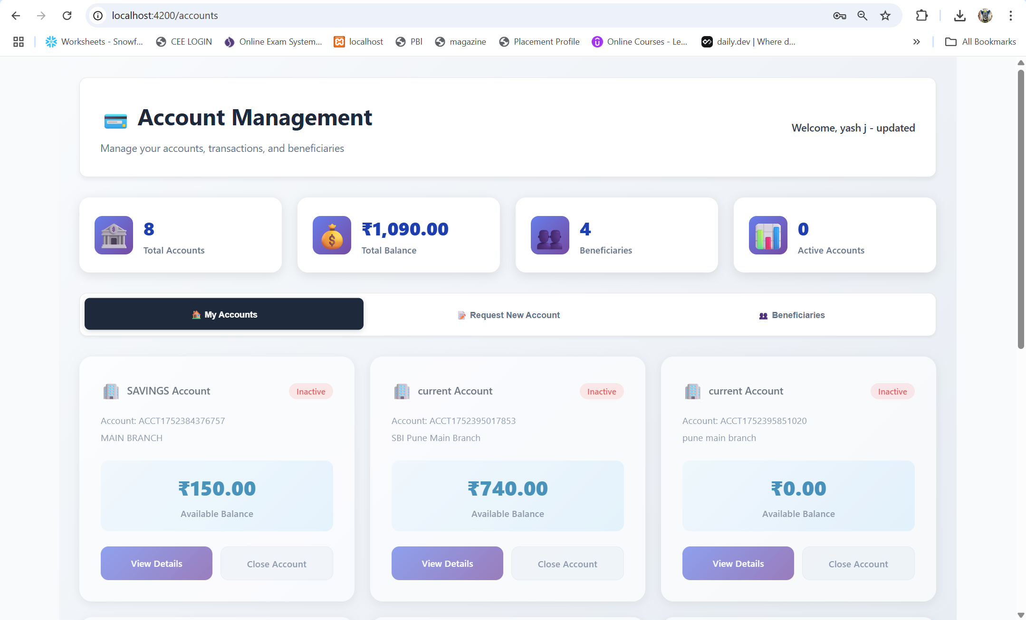

#### 6. Customer Account Request Component (/request-account)

* Purpose: New account application for customers
* Features:  
    
  Multi-step account opening process  
  Document upload capability  
  Account type selection (Savings, Current, etc.)  
  Branch selection with IFSC code integration  
  Real-time application status tracking
* Multi-step account opening process
* Document upload capability
* Account type selection (Savings, Current, etc.)
* Branch selection with IFSC code integration
* Real-time application status tracking
* Connected Services: AccountRequestService, BankService
* Workflow: Form submission → Employee review → Approval/Rejection

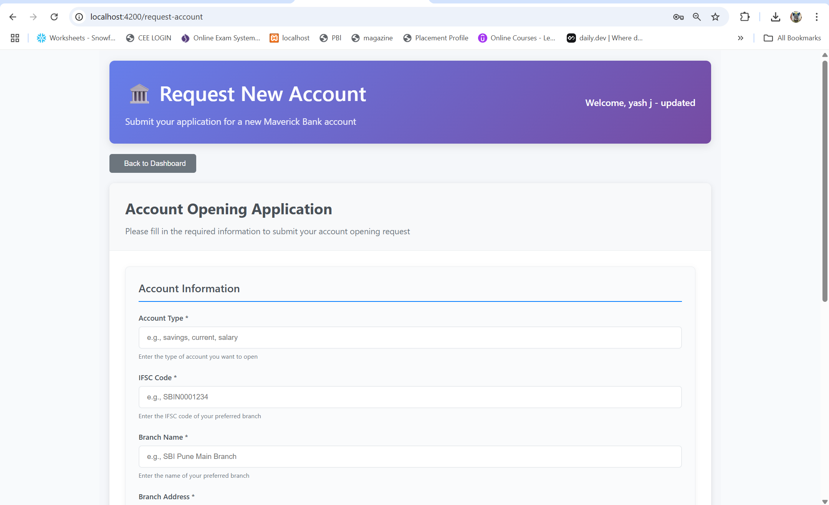

#### 7. Employee Account Management Component (/employee-accounts)

* Purpose: Employee tools for account operations
* Features:  
    
  Account approval workflow  
  Customer account search and filtering  
  Account modification capabilities  
  Bulk operations for efficiency  
  Audit trail maintenance
* Account approval workflow
* Customer account search and filtering
* Account modification capabilities
* Bulk operations for efficiency
* Audit trail maintenance
* Connected Services: AccountManagementService, UserManagementService
* Access Control: Employee and Admin roles only

### Loan Management Components

#### 8. Loan Management Component (/loan-management)

* Purpose: Complete loan lifecycle management
* Features:  
    
  Loan application processing  
  EMI calculation with interactive sliders  
  Loan status tracking and updates  
  Document management for loan processing  
  Payment history and upcoming EMI alerts
* Loan application processing
* EMI calculation with interactive sliders
* Loan status tracking and updates
* Document management for loan processing
* Payment history and upcoming EMI alerts
* Connected Services: LoanService, AccountManagementService
* Key Functionality: End-to-end loan processing workflow

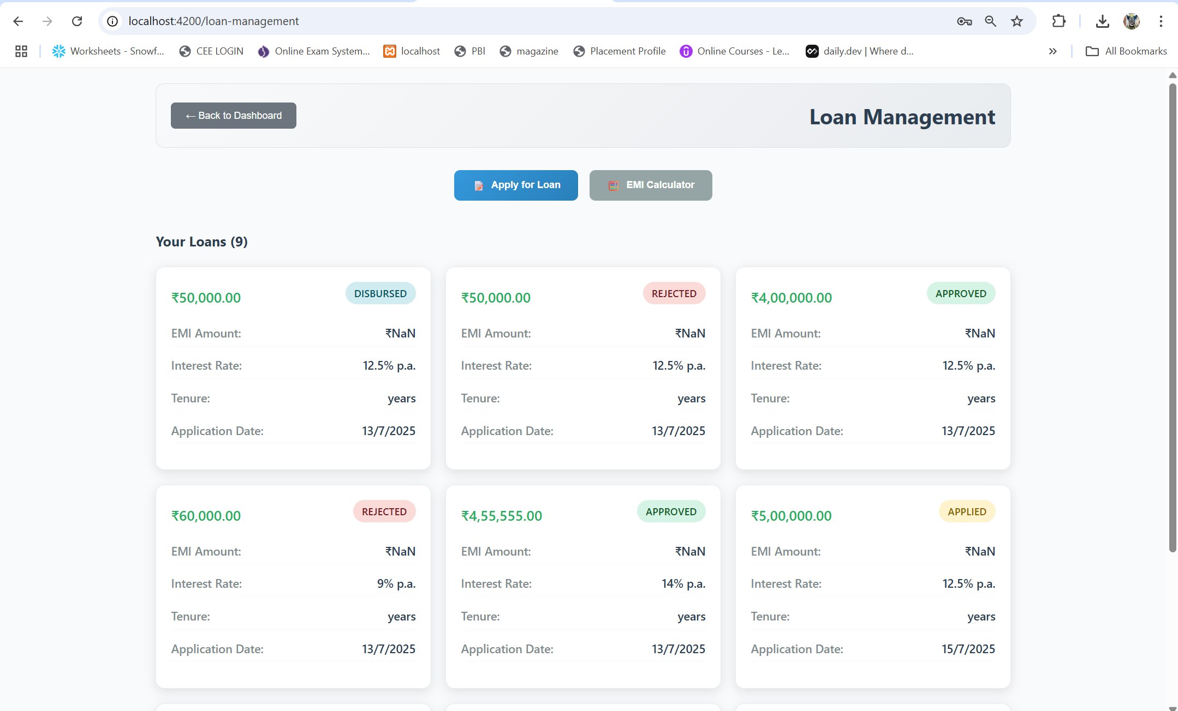

#### 9. Loan Type Management Component (/loan-type-management)

* Purpose: Administrative loan product configuration
* Features:  
    
  Create and modify loan products  
  Interest rate management  
  Tenure and amount limit configuration  
  Loan eligibility criteria setup  
  Product activation/deactivation
* Create and modify loan products
* Interest rate management
* Tenure and amount limit configuration
* Loan eligibility criteria setup
* Product activation/deactivation
* Connected Services: LoanTypeService
* Access Control: Admin role only

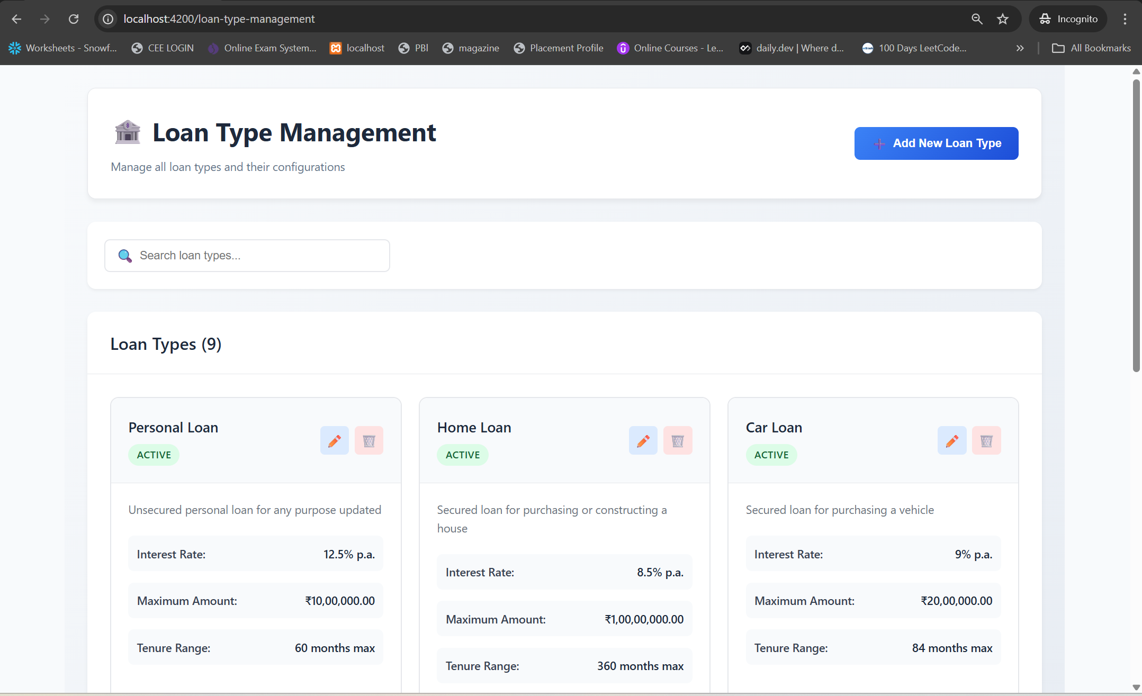

### Financial Transaction Components

#### 10. Money Transfer Component (/money-transfer)

* Purpose: Secure fund transfer operations
* Features:  
    
  NEFT/RTGS/IMPS transfer options  
  Beneficiary management integration  
  Transaction limits and validation  
  Multi-factor authentication for high-value transfers  
  Transfer scheduling and recurring payments
* NEFT/RTGS/IMPS transfer options
* Beneficiary management integration
* Transaction limits and validation
* Multi-factor authentication for high-value transfers
* Transfer scheduling and recurring payments
* Connected Services: MoneyTransferService, BeneficiaryService
* Security: Multi-layer validation, fraud detection

#### 11. Transactions Component (/transactions)

* Purpose: Transaction history and management
* Features:  
    
  Comprehensive transaction listing with filters  
  Date range selection and search functionality  
  Transaction categorization and tagging  
  Export capabilities (PDF, Excel)  
  Dispute resolution initiation
* Comprehensive transaction listing with filters
* Date range selection and search functionality
* Transaction categorization and tagging
* Export capabilities (PDF, Excel)
* Dispute resolution initiation
* Connected Services: TransactionService, ReportService
* Analytics: Spending patterns, category analysis

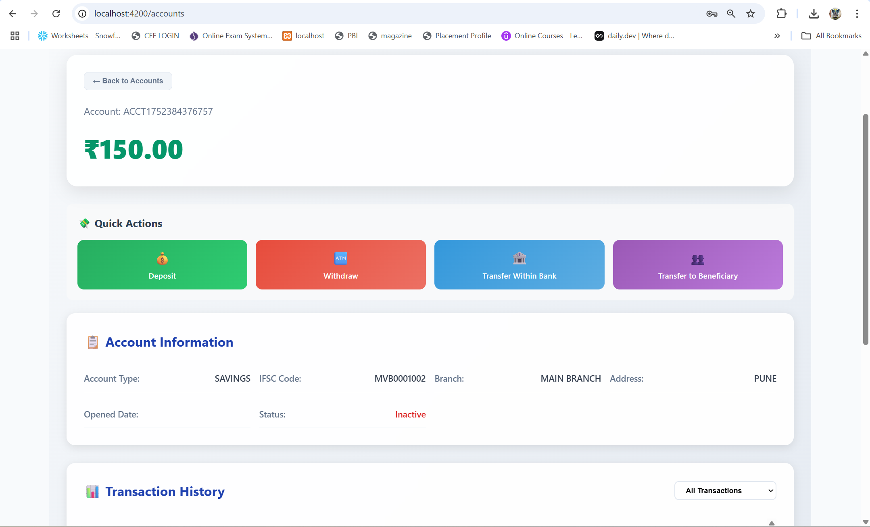

#### 12. Beneficiaries Component (/beneficiaries)

* Purpose: Payee management for transfers
* Features:  
    
  Add/edit/delete beneficiaries  
  Beneficiary verification workflow  
  Favorite beneficiaries for quick access  
  Bulk import/export functionality  
  Transaction history per beneficiary
* Add/edit/delete beneficiaries
* Beneficiary verification workflow
* Favorite beneficiaries for quick access
* Bulk import/export functionality
* Transaction history per beneficiary
* Connected Services: BeneficiaryService, MoneyTransferService
* Security: Account verification, fraud prevention

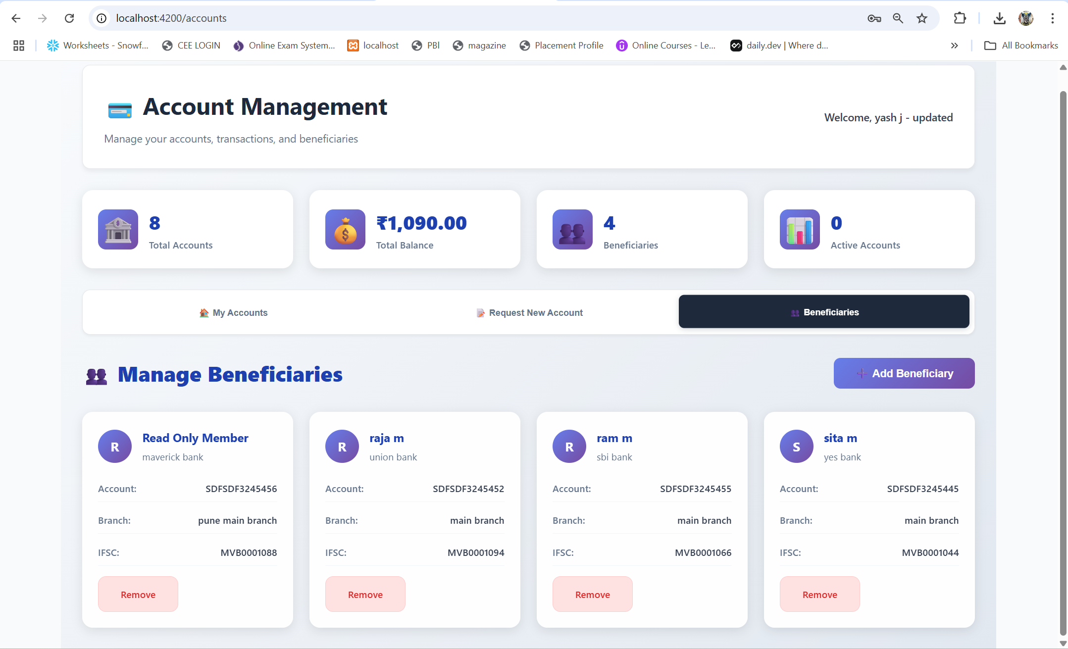

### Reporting Components

#### 13. Customer Reports Page Component (/customer-reports)

* Purpose: Customer-focused reporting and analytics
* Features:  
    
  Account statements with customizable date ranges  
  Transaction analysis and spending insights  
  Tax computation assistance  
  Financial goal tracking  
  Downloadable reports in multiple formats
* Account statements with customizable date ranges
* Transaction analysis and spending insights
* Tax computation assistance
* Financial goal tracking
* Downloadable reports in multiple formats
* Connected Services: ReportService, AccountManagementService
* Analytics: Personal financial insights, trends

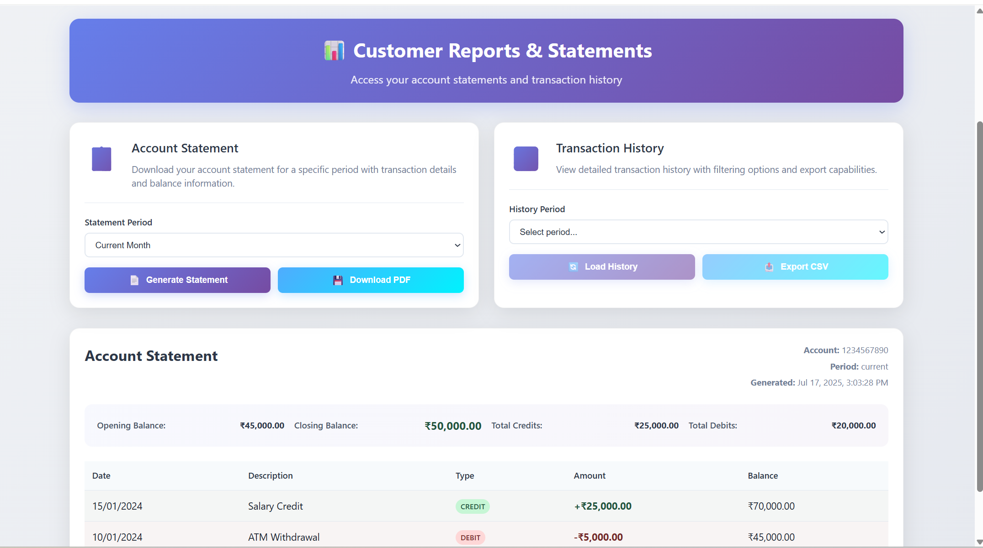

#### 14. Employee Reports Page Component (/employee-reports)

* Purpose: Employee and admin reporting tools
* Features:  
    
  Customer portfolio analysis  
  Account opening statistics  
  Loan portfolio performance  
  Branch-wise performance metrics  
  Compliance and audit reports
* Customer portfolio analysis
* Account opening statistics
* Loan portfolio performance
* Branch-wise performance metrics
* Compliance and audit reports
* Connected Services: ReportService, UserManagementService
* Access Control: Employee and Admin roles

### Administrative Components

#### 15. User Management Component (/user-management)

* Purpose: Administrative user operations
* Features:  
    
  User creation and profile management  
  Role assignment and permission management  
  Account linking and unlinking  
  User activity monitoring  
  Bulk user operations
* User creation and profile management
* Role assignment and permission management
* Account linking and unlinking
* User activity monitoring
* Bulk user operations
* Connected Services: UserManagementService, AuthService
* Access Control: Admin role only

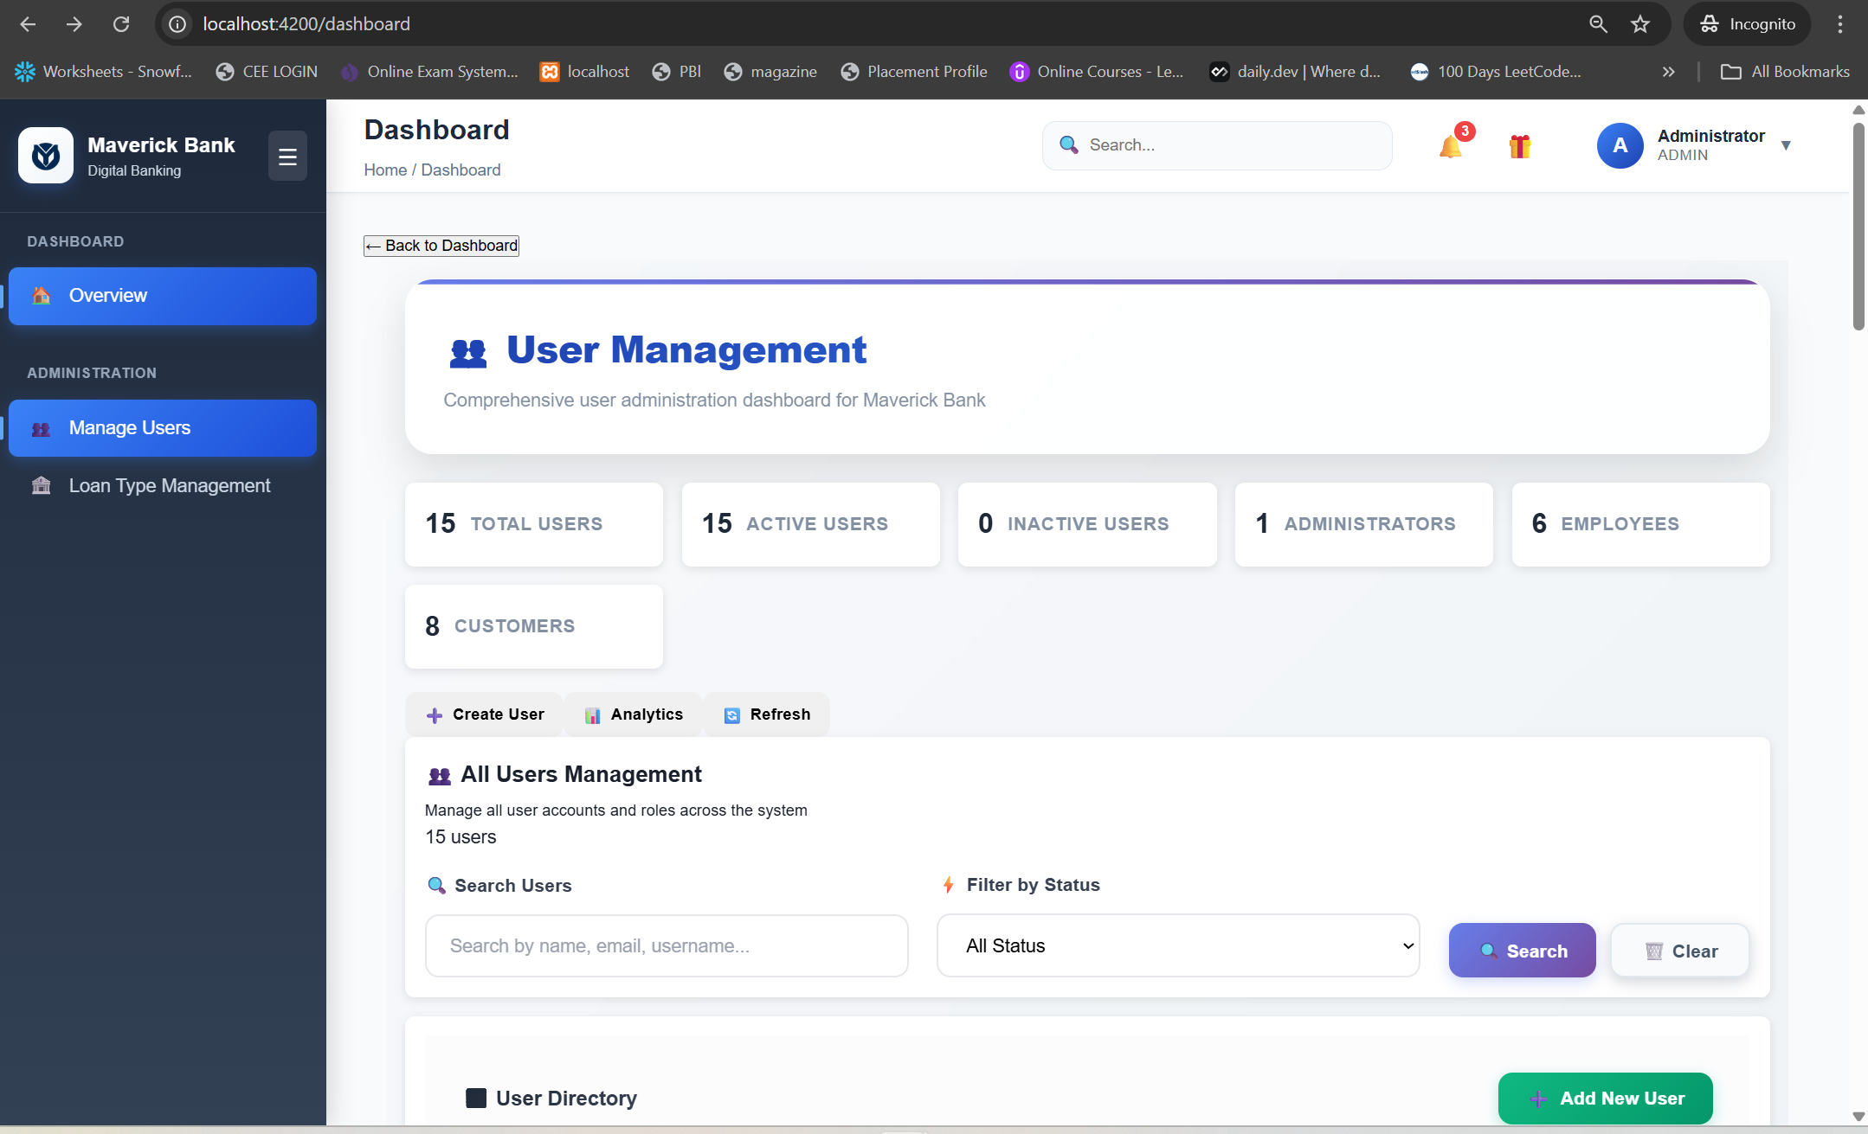

#### 16. Account Approval Component (/account-approval)

* Purpose: Employee workflow for account approvals
* Features:  
    
  Pending request queue management  
  Document verification interface  
  Approval/rejection workflow with comments  
  Risk assessment tools  
  Batch processing capabilities
* Pending request queue management
* Document verification interface
* Approval/rejection workflow with comments
* Risk assessment tools
* Batch processing capabilities
* Connected Services: AccountRequestService, AccountManagementService
* Workflow: Review → Verify → Approve/Reject → Notify

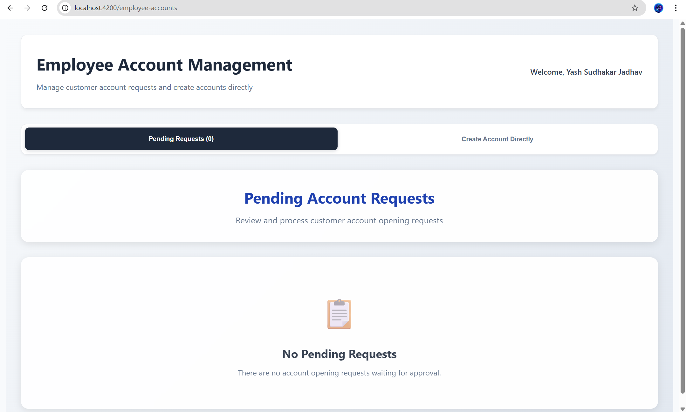

#### 17. Notifications Component (/notifications)

* Purpose: Global notification system
* Features:  
    
  Real-time notifications for account activities  
  System alerts and maintenance notices  
  Personalized financial recommendations  
  Push notification preferences  
  Notification history and management
* Real-time notifications for account activities
* System alerts and maintenance notices
* Personalized financial recommendations
* Push notification preferences
* Notification history and management
* Connected Services: NotificationService
* Types: Success, Error, Warning, Info notifications

## 🛣️ Routing Explanation

### Route Structure

The application uses Angular's powerful routing system with sophisticated guard mechanisms for security and user experience.

### Public Routes (No Authentication Required)

### Protected Routes (Authentication Required)

All protected routes use AuthGuard to ensure user authentication:

### Role-Based Protected Routes

Advanced routes using both AuthGuard and RoleGuard for role-based access:

Customer-Only Routes

Employee & Admin Routes

Admin-Only Routes

Guard Implementation

#### AuthGuard Protection

* Verifies JWT token presence and validity
* Automatically redirects to login if token is expired
* Loads user profile if token exists but user data is missing
* Maintains session continuity across browser refreshes

#### RoleGuard Protection

* Checks user roles against required route roles
* Provides granular access control
* Shows appropriate error messages for unauthorized access
* Redirects to dashboard if access is denied

### Wildcard Route

Catches all undefined routes and redirects to login for security.

## 🏪 State Management

The application uses a service-based state management pattern rather than a complex state store, optimized for banking application requirements:

### Service-Based Architecture

* Centralized Services: Each domain (Auth, Accounts, Loans) has dedicated services
* RxJS Observables: Reactive state management with BehaviorSubjects
* Local State: Component-level state for UI-specific data
* Session Persistence: Critical data stored in localStorage with encryption

### Key State Management Services

#### AuthService State

* User authentication status
* JWT token management
* User profile and role information
* Session persistence and restoration

#### AccountManagementService State

* Current user accounts
* Selected account information
* Account transaction cache
* Real-time balance updates

#### NotificationService State

* Global notification queue
* User preference settings
* Notification history

### Benefits of This Approach

* Simplicity: Easy to understand and maintain
* Performance: Minimal overhead compared to complex state stores
* Security: Banking-specific security considerations built-in
* Flexibility: Easy to extend for new features

## 🔧 Services

### Authentication & Security Services

#### AuthService (auth.service.ts)

* Purpose: Complete authentication lifecycle management
* Key Methods:  
    
  login(credentials): JWT-based user authentication  
  register(userData): New user registration  
  logout(): Secure session termination  
  getCurrentUser(): Active user profile retrieval  
  isTokenExpired(): Token validity verification  
  loadUserProfile(): User data restoration from token
* login(credentials): JWT-based user authentication
* register(userData): New user registration
* logout(): Secure session termination
* getCurrentUser(): Active user profile retrieval
* isTokenExpired(): Token validity verification
* loadUserProfile(): User data restoration from token
* Security Features:   
    
  Automatic token refresh  
  Secure token storage  
  Session timeout handling  
  Role-based access verification
* Automatic token refresh
* Secure token storage
* Session timeout handling
* Role-based access verification

### Account Management Services

#### AccountManagementService (account-management.service.ts)

* Purpose: Core account operations and data management
* Key Methods:  
    
  getUserAccounts(): Retrieve user's accounts  
  getAccountDetails(accountId): Detailed account information  
  updateAccountStatus(): Account activation/deactivation  
  getAccountTransactions(): Transaction history retrieval  
  generateStatement(): Account statement generation
* getUserAccounts(): Retrieve user's accounts
* getAccountDetails(accountId): Detailed account information
* updateAccountStatus(): Account activation/deactivation
* getAccountTransactions(): Transaction history retrieval
* generateStatement(): Account statement generation
* Features: Real-time balance updates, transaction caching, multi-account support

#### AccountRequestService (account-request.service.ts)

* Purpose: New account application workflow management
* Key Methods:  
    
  submitAccountRequest(): New account application submission  
  getPendingRequests(): Employee pending approval queue  
  approveRequest(): Account approval processing  
  rejectRequest(): Account rejection with comments  
  getRequestStatus(): Application status tracking
* submitAccountRequest(): New account application submission
* getPendingRequests(): Employee pending approval queue
* approveRequest(): Account approval processing
* rejectRequest(): Account rejection with comments
* getRequestStatus(): Application status tracking
* Workflow Integration: Complete request-to-approval pipeline

### Financial Services

#### LoanService (loan.service.ts)

* Purpose: Comprehensive loan management operations
* Key Methods:  
    
  applyForLoan(): Loan application submission  
  calculateEMI(): Real-time EMI calculations  
  getUserLoans(): User loan portfolio  
  updateLoanStatus(): Employee loan processing  
  getLoanDetails(): Detailed loan information
* applyForLoan(): Loan application submission
* calculateEMI(): Real-time EMI calculations
* getUserLoans(): User loan portfolio
* updateLoanStatus(): Employee loan processing
* getLoanDetails(): Detailed loan information
* Features: EMI calculator, loan eligibility check, document management

#### LoanTypeService (loan-type.service.ts)

* Purpose: Administrative loan product management
* Key Methods:  
    
  createLoanType(): New loan product creation  
  updateLoanType(): Loan product modification  
  getAllLoanTypes(): Available loan products  
  toggleLoanTypeStatus(): Product activation/deactivation
* createLoanType(): New loan product creation
* updateLoanType(): Loan product modification
* getAllLoanTypes(): Available loan products
* toggleLoanTypeStatus(): Product activation/deactivation
* Admin Features: Interest rate management, eligibility criteria setup

#### MoneyTransferService (money-transfer.service.ts)

* Purpose: Secure fund transfer operations
* Key Methods:  
    
  initiateTransfer(): Fund transfer initiation  
  verifyBeneficiary(): Beneficiary account verification  
  getTransferLimits(): User transfer limits  
  scheduleTransfer(): Future-dated transfer scheduling  
  getTransferHistory(): Transfer transaction history
* initiateTransfer(): Fund transfer initiation
* verifyBeneficiary(): Beneficiary account verification
* getTransferLimits(): User transfer limits
* scheduleTransfer(): Future-dated transfer scheduling
* getTransferHistory(): Transfer transaction history
* Security: Multi-factor authentication, fraud detection, limit enforcement

#### TransactionService (transaction.service.ts)

* Purpose: Transaction processing and history management
* Key Methods:  
    
  getTransactionHistory(): Comprehensive transaction retrieval  
  searchTransactions(): Advanced transaction filtering  
  categorizeTransaction(): Transaction categorization  
  exportTransactions(): Data export functionality  
  disputeTransaction(): Transaction dispute initiation
* getTransactionHistory(): Comprehensive transaction retrieval
* searchTransactions(): Advanced transaction filtering
* categorizeTransaction(): Transaction categorization
* exportTransactions(): Data export functionality
* disputeTransaction(): Transaction dispute initiation
* Analytics: Spending analysis, transaction patterns, reporting

### Support Services

#### BeneficiaryService (beneficiary.service.ts)

* Purpose: Payee management for transfers
* Key Methods:  
    
  addBeneficiary(): New beneficiary registration  
  verifyBeneficiary(): Account verification process  
  updateBeneficiary(): Beneficiary information updates  
  deleteBeneficiary(): Beneficiary removal  
  getFavoriteBeneficiaries(): Quick access payees
* addBeneficiary(): New beneficiary registration
* verifyBeneficiary(): Account verification process
* updateBeneficiary(): Beneficiary information updates
* deleteBeneficiary(): Beneficiary removal
* getFavoriteBeneficiaries(): Quick access payees
* Features: Bulk operations, verification workflow, favorite management

#### ReportService (report.service.ts)

* Purpose: Report generation and analytics
* Key Methods:  
    
  generateAccountStatement(): Detailed account statements  
  getSpendingAnalysis(): Personal spending insights  
  generateTaxReport(): Tax computation assistance  
  getPortfolioAnalysis(): Investment portfolio analysis  
  exportReport(): Multi-format report export
* generateAccountStatement(): Detailed account statements
* getSpendingAnalysis(): Personal spending insights
* generateTaxReport(): Tax computation assistance
* getPortfolioAnalysis(): Investment portfolio analysis
* exportReport(): Multi-format report export
* Formats: PDF, Excel, CSV export options

#### UserManagementService (user-management.service.ts)

* Purpose: Administrative user operations
* Key Methods:  
    
  createUser(): New user account creation  
  updateUserProfile(): User information updates  
  assignRole(): Role management operations  
  deactivateUser(): User account deactivation  
  getUserActivity(): Activity monitoring and logs
* createUser(): New user account creation
* updateUserProfile(): User information updates
* assignRole(): Role management operations
* deactivateUser(): User account deactivation
* getUserActivity(): Activity monitoring and logs
* Admin Features: Bulk operations, role management, audit trails

### Utility Services

#### NotificationService (notification.service.ts)

* Purpose: Global notification and messaging system
* Key Methods:  
    
  showSuccess(): Success message display  
  showError(): Error message handling  
  showWarning(): Warning notifications  
  showInfo(): Informational messages  
  clearNotifications(): Notification queue management
* showSuccess(): Success message display
* showError(): Error message handling
* showWarning(): Warning notifications
* showInfo(): Informational messages
* clearNotifications(): Notification queue management
* Features: Auto-dismiss, persistent notifications, user preferences

#### LoadingService (loading.service.ts)

* Purpose: Application loading state management
* Key Methods:  
    
  setLoading(): Global loading state control  
  isLoading(): Loading state observation  
  startOperation(): Operation-specific loading  
  completeOperation(): Loading completion handling
* setLoading(): Global loading state control
* isLoading(): Loading state observation
* startOperation(): Operation-specific loading
* completeOperation(): Loading completion handling
* UX Features: Prevents multiple simultaneous requests, loading indicators

#### NavigationService (navigation.service.ts)

* Purpose: Navigation utilities and route management
* Key Methods:  
    
  navigateToRoute(): Programmatic navigation  
  goBack(): Browser history navigation  
  getCurrentRoute(): Active route information  
  setReturnUrl(): Post-login navigation
* navigateToRoute(): Programmatic navigation
* goBack(): Browser history navigation
* getCurrentRoute(): Active route information
* setReturnUrl(): Post-login navigation
* Features: Breadcrumb management, deep linking support

### HTTP Communication Pattern

All services follow a consistent pattern:  
- Base URL Configuration: Centralized API endpoint management  
- Error Handling: Consistent error response processing  
- Loading States: Integrated loading state management  
- Retry Logic: Automatic retry for failed requests  
- Caching: Strategic response caching for performance

## 🔐 Authentication Flow

### Complete Authentication Workflow

#### 1. Initial User Authentication

Steps:  
1. User submits login credentials  
2. AuthService sends credentials to backend /api/auth/login  
3. Backend validates credentials and returns JWT token  
4. Token is stored securely in localStorage  
5. User profile is loaded and stored in BehaviorSubject  
6. User is redirected to role-appropriate dashboard

#### 2. JWT Token Management

* Token Storage: Secure localStorage with encryption considerations
* Token Structure: Contains user ID, roles, and expiration timestamp
* Token Validation: Automatic expiration checking on each route navigation
* Token Refresh: Automatic refresh before expiration (when implemented)

#### 3. Session Persistence

#### 4. Route Protection Implementation

AuthGuard Protection Flow:

RoleGuard Protection Flow:

#### 5. Automatic Token Interception

### Security Features

#### Token Security

* JWT tokens contain minimal sensitive information
* Automatic logout on token expiration
* Secure transmission over HTTPS
* Client-side token validation

#### Session Management

* Configurable session timeout
* Activity-based session renewal
* Secure logout with token invalidation
* Multi-tab session synchronization

#### Role-Based Access Control (RBAC)

* Granular permission system
* Route-level protection
* Component-level feature toggles
* API endpoint protection

#### Fraud Prevention

* Session monitoring for unusual activity
* Failed login attempt tracking
* IP address validation (backend)
* Multi-factor authentication (planned)

## 📱 Responsive Design

### Mobile-First Design Philosophy

The application follows a mobile-first approach ensuring optimal experience across all devices.

### CSS Grid & Flexbox Layout System

### Breakpoint System

### Responsive Features

#### Navigation Adaptation

* Desktop: Full horizontal navigation with dropdowns
* Tablet: Collapsible navigation with icons
* Mobile: Hamburger menu with slide-out drawer

#### Component Responsiveness

* Cards: Fluid width with minimum/maximum constraints
* Tables: Horizontal scroll on mobile, stacked layout
* Forms: Single-column layout on mobile, multi-column on desktop
* Buttons: Full-width on mobile, inline on desktop

#### Typography Scaling

### Touch-Friendly Interface

* Button Sizing: Minimum 44px tap targets
* Spacing: Adequate spacing between interactive elements
* Gestures: Swipe navigation for mobile users
* Accessibility: High contrast, readable fonts, keyboard navigation

### Performance Optimizations

* Lazy Loading: Images and non-critical components
* CSS Optimization: Minimal critical CSS, async loading
* Bundle Splitting: Route-based code splitting
* Caching: Strategic component and data caching

## 🌐 API Integration

### Backend Communication Architecture

#### Base API Configuration

#### Proxy Configuration for Development

### API Communication Patterns

#### Standardized HTTP Methods

* GET: Data retrieval (accounts, transactions, reports)
* POST: Data creation (new accounts, transactions, loans)
* PUT: Data updates (profile updates, account modifications)
* DELETE: Data removal (beneficiaries, loan applications)

#### Error Response Handling

* 401 Unauthorized: Automatic logout and redirect to login
* 403 Forbidden: Permission denied notification
* 404 Not Found: Resource not found handling
* 500 Server Error: Generic server error notification
* Network Errors: Offline/connectivity issue handling

### Caching Strategy

* User Profile: Cached until logout
* Account Data: 5-minute cache with refresh option
* Static Data: Long-term caching (loan types, branches)
* Transactions: Smart caching with pagination

## 🚀 How to Run the Project

### Prerequisites

Before running the Maverick Bank Frontend, ensure you have the following installed:

* Node.js: Version 18.x or later
* npm: Version 9.x or later (comes with Node.js)
* Angular CLI: Version 20.x
* Git: For version control
* VS Code: Recommended IDE with Angular extensions

### System Requirements

* Operating System: Windows 10/11, macOS 10.15+, or Linux
* RAM: Minimum 8GB (16GB recommended for development)
* Storage: At least 2GB free space
* Browser: Chrome 90+, Firefox 88+, Safari 14+, or Edge 90+

### Installation Steps

#### 1. Clone the Repository

#### 2. Install Dependencies

This will install all required packages including:  
- Angular framework and CLI tools  
- TypeScript compiler  
- Development dependencies  
- Testing frameworks

#### 3. Environment Configuration

Verify the proxy configuration in proxy.conf.json:

#### 4. Start the Development Server

#### 5. Access the Application

* Open your browser and navigate to: http://localhost:4200
* The application will automatically reload when you make changes to the source files

### Development Commands

#### Start Development Server

#### Build Commands

#### Testing Commands

#### Code Quality Commands

### Backend Requirements

This frontend application requires the Maverick Bank Backend to be running:

1. Backend Server: Must be running on http://localhost:9090
2. Database: Backend should have proper database connectivity
3. API Endpoints: All required endpoints should be available

### Environment Variables (if applicable)

Create a .env file in the root directory if environment-specific configurations are needed:

API_BASE_URL=http://localhost:9090/api  
ENVIRONMENT=development

### Common Development Issues & Solutions

#### Port Already in Use

#### Node Modules Issues

#### Angular CLI Issues

### Development Workflow

1. Start backend server on port 9090
2. Start frontend development server: npm start
3. Access application at http://localhost:4200
4. Make changes to source files
5. View changes automatically in browser
6. Run tests: npm test
7. Build for production: npm run build

## 🔮 Future Improvements

### Immediate Enhancements (Next Release)

#### 1. UPI Integration

* QR Code Generation: Dynamic QR codes for payments
* UPI Payment Gateway: Integration with major UPI providers
* Contact-based Payments: Pay using mobile numbers
* Bill Splitting: Shared expense management
* Merchant Payments: Business transaction support

#### 2. Enhanced Notification System

* Real-time Push Notifications: WebSocket-based instant alerts
* Email Notifications: Transaction confirmations and statements
* SMS Integration: OTP and critical alerts
* In-app Notification Center: Comprehensive message management
* Notification Preferences: Granular control over alert types

#### 3. Advanced Security Features

* Two-Factor Authentication (2FA): SMS and app-based authentication
* Biometric Authentication: Fingerprint and face recognition
* Transaction PIN: Additional security for high-value transactions
* Device Registration: Trusted device management
* Session Management: Enhanced security monitoring

### Medium-term Features (6-12 months)

#### 4. Investment Management

* Mutual Fund Integration: SIP and lump-sum investments
* Stock Trading: Basic equity trading functionality
* Portfolio Analytics: Investment performance tracking
* Risk Assessment: Investor profiling and recommendations
* Goal-based Investing: Systematic investment planning

#### 5. Advanced Analytics & AI

* Spending Insights: AI-powered financial behavior analysis
* Budget Management: Automated budget creation and tracking
* Fraud Detection: Machine learning-based anomaly detection
* Personalized Recommendations: Financial product suggestions
* Predictive Analytics: Cash flow forecasting

#### 6. Enhanced Admin Features

* Advanced Reporting Dashboard: Real-time business intelligence
* Audit Trail Management: Comprehensive activity logging
* Bulk Operations Interface: Mass data processing capabilities
* Workflow Automation: Approval process automation
* Compliance Monitoring: Regulatory requirement tracking

### Long-term Vision (1-2 years)

#### 7. Multi-channel Banking

* Voice Banking: Voice command integration
* Chatbot Support: AI-powered customer service
* Video Banking: Remote banking assistance
* Social Media Integration: Social payment features
* IoT Integration: Connected device payments

#### 8. Blockchain Integration

* Cryptocurrency Support: Digital currency transactions
* Smart Contracts: Automated loan and insurance processing
* Decentralized Identity: Blockchain-based KYC
* Cross-border Payments: International transfer optimization
* Supply Chain Finance: Trade finance solutions

#### 9. Open Banking Architecture

* Third-party Integrations: Fintech service partnerships
* API Marketplace: Developer ecosystem
* Account Aggregation: Multi-bank view functionality
* Financial Marketplace: Integrated financial services
* PFM Integration: Personal finance management tools

### Technical Improvements

#### 10. Performance Optimization

* Progressive Web App (PWA): Offline functionality
* Code Splitting: Advanced lazy loading strategies
* Caching Strategy: Enhanced performance optimization
* CDN Integration: Global content delivery
* Bundle Optimization: Reduced application size

#### 11. Testing & Quality Assurance

* End-to-End Testing: Comprehensive automation testing
* Performance Testing: Load and stress testing
* Security Testing: Vulnerability assessment
* Accessibility Testing: WCAG compliance
* Cross-browser Testing: Enhanced compatibility

#### 12. DevOps & Deployment

* CI/CD Pipeline: Automated build and deployment
* Containerization: Docker-based deployment
* Cloud Migration: Scalable cloud infrastructure
* Monitoring & Logging: Application performance monitoring
* Disaster Recovery: Business continuity planning

### User Experience Enhancements

#### 13. Accessibility Improvements

* Screen Reader Support: Enhanced accessibility
* Keyboard Navigation: Complete keyboard support
* High Contrast Mode: Visual accessibility options
* Multi-language Support: Localization capabilities
* Voice Control: Accessibility through voice commands

#### 14. Customization Features

* Themeable Interface: User-selectable themes
* Dashboard Customization: Personalized layouts
* Widget Library: Modular dashboard components
* Notification Preferences: Granular control options
* Language Preferences: Multi-language support

### Integration Roadmap

* Payment Gateway Expansion: Multiple payment providers
* Banking Partner APIs: Inter-bank connectivity
* Government Services: Tax filing and compliance
* Insurance Integration: Comprehensive financial planning
* Credit Bureau Integration: Enhanced credit management

These improvements will be prioritized based on user feedback, business requirements, and technological advancements, ensuring Maverick Bank remains at the forefront of digital banking innovation.

## 👥 Credits

### Development Team

#### Lead Developer

* Name: Yash Jadhav
* Role: Full-Stack Developer
* Responsibilities:   
    
  Frontend architecture and implementation  
  Backend API integration  
  UI/UX design and responsive development  
  Security implementation and testing
* Frontend architecture and implementation
* Backend API integration
* UI/UX design and responsive development
* Security implementation and testing

### Technologies & Frameworks Used

#### Frontend Framework

* Angular 20.0.0 - Google's TypeScript-based web application framework
* TypeScript 5.8.2 - Microsoft's typed superset of JavaScript
* RxJS 7.8.0 - Reactive Extensions for JavaScript

#### Development Tools

* Angular CLI 20.0.5 - Command-line interface for Angular development
* Node.js - JavaScript runtime environment
* npm - Package manager for JavaScript

#### Testing Framework

* Jasmine 5.7.0 - Behavior-driven development framework
* Karma 6.4.0 - Test runner for JavaScript

#### Build & Development

* Webpack - Module bundler (via Angular CLI)
* TypeScript Compiler - Code compilation and type checking

### Design & UI Resources

#### Typography

* Google Fonts (Inter) - Modern, clean typography
* Font Awesome - Icon library (if used)

#### Design Inspiration

* Modern Banking Interfaces - Contemporary fintech design patterns
* Material Design Principles - Google's design language
* Apple Human Interface Guidelines - iOS design standards

### Third-Party Libraries & Services

#### CSS Frameworks & Utilities

* Custom CSS Grid - Modern layout system
* Flexbox - Flexible layout model
* CSS Variables - Dynamic theming support

#### Development Utilities

* Prettier - Code formatting tool
* ESLint - JavaScript/TypeScript linting (if configured)

### Learning Resources & Documentation

#### Official Documentation

* Angular Documentation - https://angular.io/docs
* TypeScript Handbook - https://www.typescriptlang.org/docs/
* RxJS Documentation - https://rxjs.dev/guide/overview

#### Community Resources

* Angular Community - https://community.angular.io/
* Stack Overflow - Problem-solving and community support
* GitHub - Code repositories and open-source contributions

### Special Acknowledgments

#### Banking Domain Expertise

* Industry best practices for banking applications
* Security standards and compliance requirements
* User experience research in financial services

#### Code Quality & Standards

* Clean Code Principles - Robert C. Martin's coding standards
* Angular Style Guide - Official Angular coding conventions
* TypeScript Best Practices - Community-driven development patterns

### Open Source Contributions

This project leverages numerous open-source technologies and frameworks. We acknowledge and appreciate the contributions of the global developer community that makes modern web development possible.

#### Package Dependencies

All package dependencies and their respective licenses are detailed in package.json and package-lock.json. We respect and comply with all open-source licenses.

### Feedback & Contributions

We welcome feedback, suggestions, and contributions from the developer community. Please refer to the contribution guidelines in the repository for more information on how to participate in this project's development.

Maverick Bank Backend

## 1. Project Overview

The Maverick Bank System is a secure, modular, and scalable backend application for managing banking operations such as customer accounts, transactions, loans, beneficiaries, and reporting. It is designed for both individual and business customers, supporting robust role-based access for customers, employees, and administrators.

**Technologies & Frameworks**

- Java 17+

- Spring Boot

- Spring Data JPA (Hibernate)

- MySQL

- Maven

- Swagger UI (OpenAPI)

- (Previously: Spring Security & JWT, now open APIs for easy testing)

**System Architecture:**

- Layered architecture: Controller → Service → Repository → Database

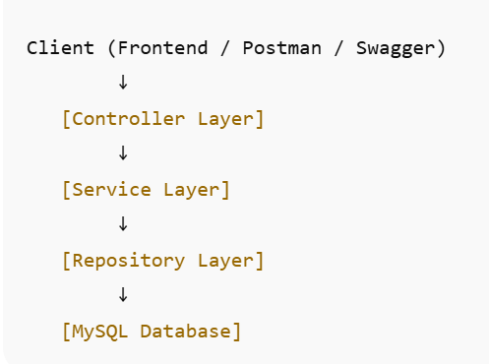

- RESTful API design

- DTOs for request/response payloads

- Modular package structure

------------------------------------------------------------

## 2. Setup Instructions

**System Requirements:**

- Java 17 or higher

- Maven 3.6+

- MySQL 8.x

**Installation Guide:**

1. Clone the repository.

2. Configure your MySQL server and create a database named `MaverickBank`.

3. Update `src/main/resources/application.properties` with your DB credentials.

4. Build the project:

```

mvn clean install

```

5. Run the backend:

```

mvn spring-boot:run

```

6. Access Swagger UI at:

`http://localhost:9090/swagger-ui.html`

**Environment Variables / Properties:**

- `spring.datasource.url` – MySQL connection string

- `spring.datasource.username` – DB username

- `spring.datasource.password` – DB password

- `server.port` – Port for backend (default: 9090)

- (JWT properties are present but not used in the current open API version)

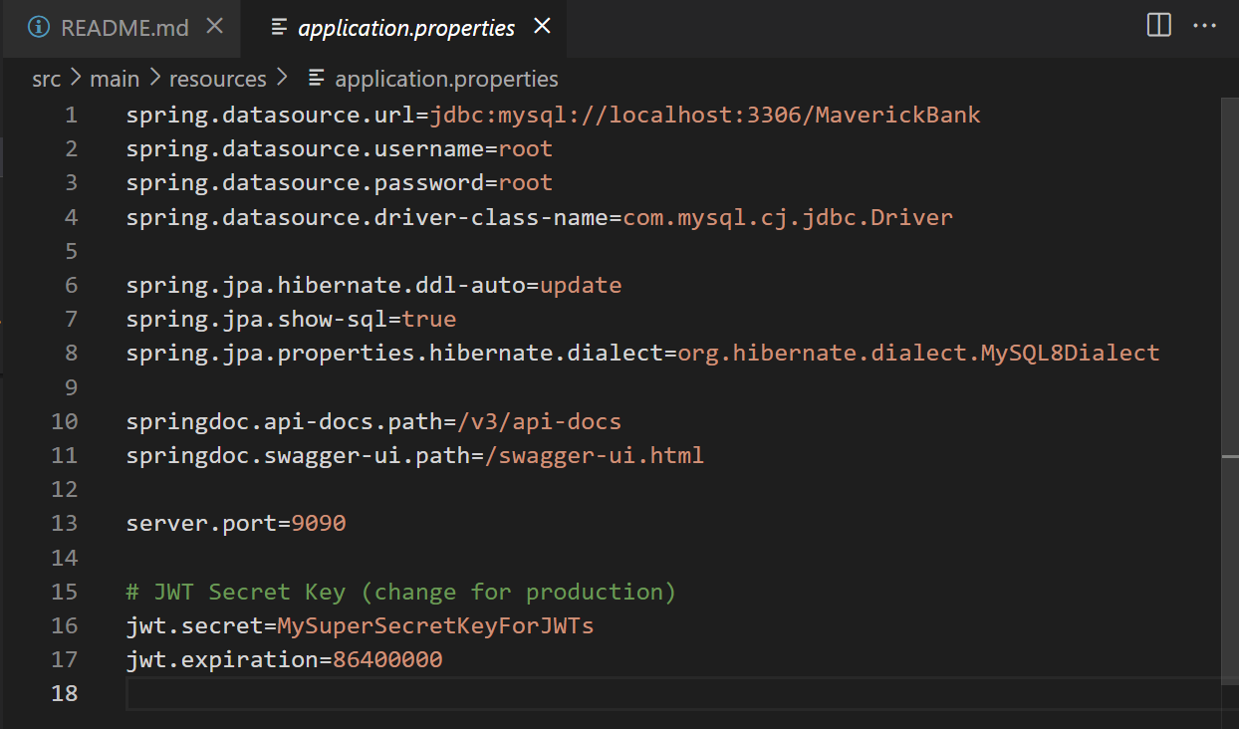

------------------------------------------------------------

## 3. API Documentation

APIs are RESTful and accept/return JSON.

Swagger UI provides interactive documentation and example payloads.

**Endpoints Overview:**

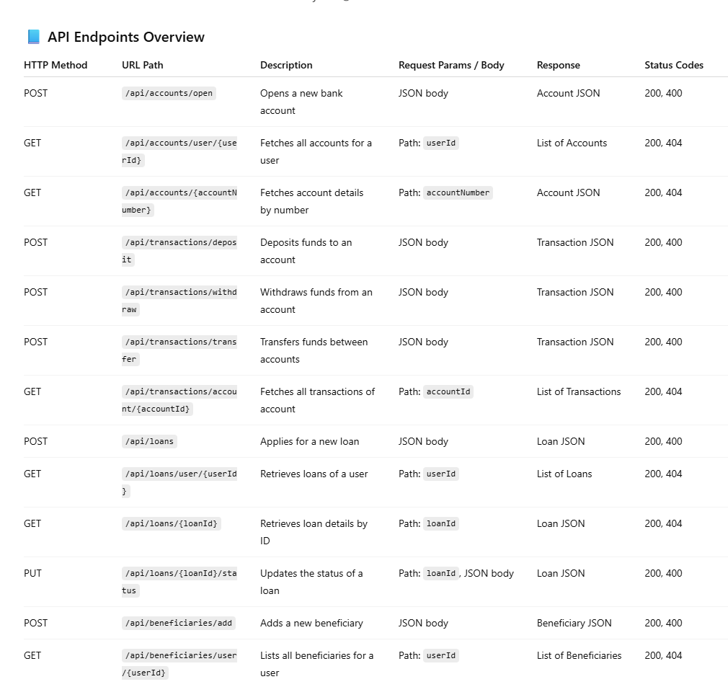

Swagger UI

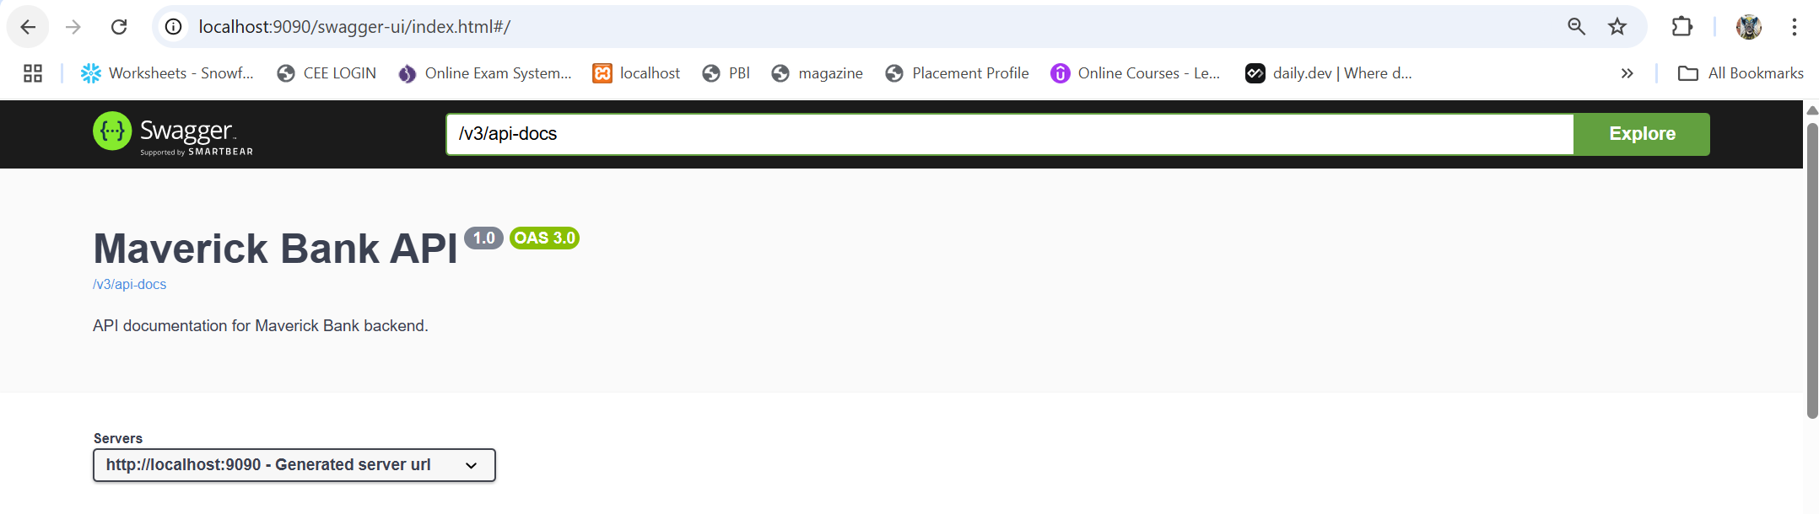

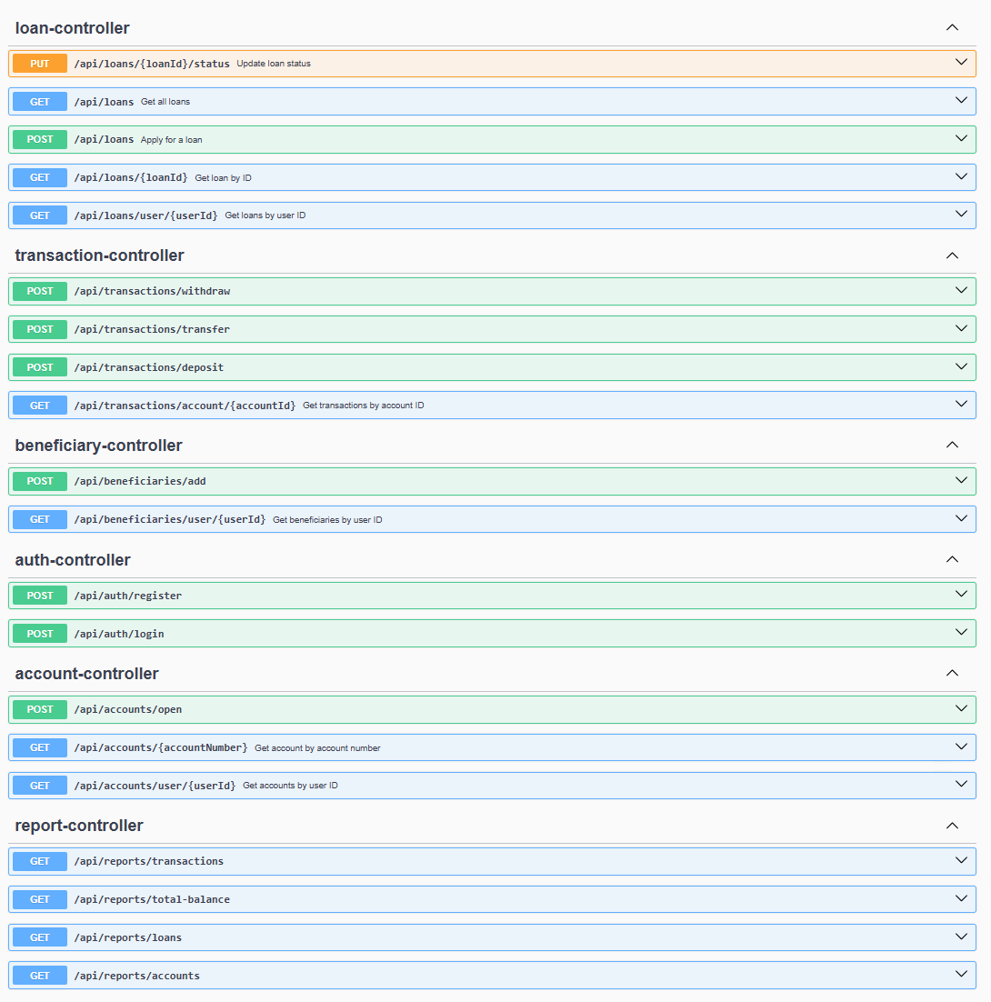

## 4. Database Schema

**Main Tables:**

- `users` (id, username, password, name, email, contactNumber, address)

- `roles` (id, name)

- `accounts` (id, accountNumber, accountType, ifscCode, branchName, branchAddress, balance, user_id)

- `transactions` (id, type, amount, date, account_id, description)

- `loans` (id, amount, interestRate, tenureMonths, status, applicationDate, user_id)

- `beneficiaries` (id, user_id, name, accountNumber, bankName, branchName, ifscCode)

**Relationships:**

- User 1—* Account

- Account 1—* Transaction

- User 1—* Loan

- User 1—* Beneficiary

- User *—* Role

ER diagram

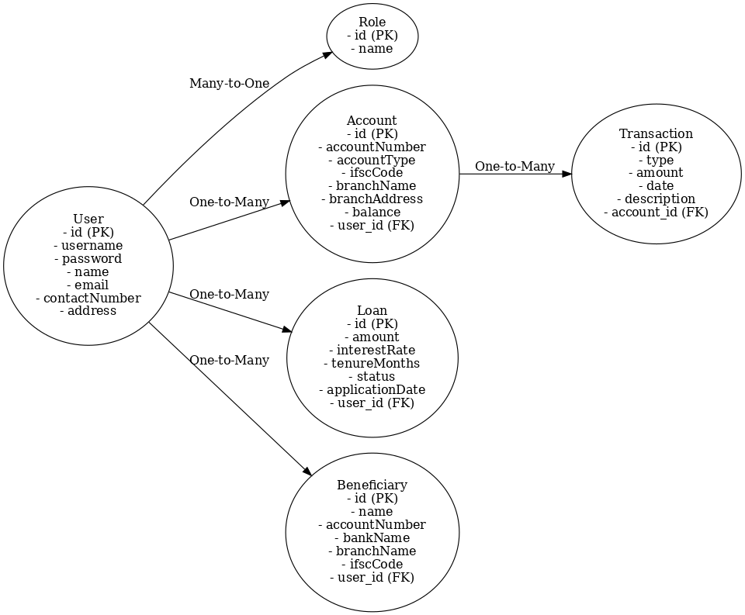

## 5. Authentication & Authorization

- **Current Version**: All APIs are open for easy testing (no authentication).

- **Planned/Previous**: JWT-based authentication, role-based access (CUSTOMER, EMPLOYEE, ADMIN).

- **Token Structure**: (If enabled) JWT with userId, roles, expiration.

- **Role-based Access**: Endpoints can be restricted by role using annotations.

------------------------------------------------------------

## 6. Business Logic / Modules

### User & Role Module

- Register, login, assign roles.

- Admin can manage users and employees.

### Account Module

- Open new account, view accounts by user/account number.

- Account types: savings, checking, business, etc.

### Transaction Module

- Deposit, withdraw, transfer funds.

- All transactions linked to accounts.

- Transaction history by account.

### Loan Module

- Apply for loan, view loans by user, update loan status.

- Loan status transitions:

- APPLIED → APPROVED/REJECTED

- APPROVED → DISBURSED

- REJECTED/DISBURSED are final

### Beneficiary Module

- Add beneficiary, view by user.

### Reporting Module

- Generate account statements, transaction history, financial reports.

------------------------------------------------------------

## 7. Error Handling

- All errors returned as JSON with user-friendly messages.

- HTTP status codes: 400 (bad request), 404 (not found), 500 (server error), etc.

- Example error response:

```json

{

"timestamp": "2025-06-27T12:00:00",

"status": 404,

"error": "Not Found",

"message": "Account not found",

"path": "/api/accounts/123"

}

```

- Backend logs technical details for debugging.

------------------------------------------------------------

## 8. Testing

- **Tools**: JUnit, Spring Boot Test, Swagger UI, Postman

- **How to run tests**:

```

mvn test

```

- **Coverage:** Service and controller layer tests.

- **Manual Testing**: All endpoints can be tested via Swagger UI/Postman.

------------------------------------------------------------

## 9. Deployment

- **Build**:

```

mvn clean install

```

- **Run**:

```

mvn spring-boot:run

```

- **Production Setup**:

- Configure `application.properties` for production DB and server.

------------------------------------------------------------

## 10. Versioning & Changelog

- **API Versioning**: (Planned) Use `/api/v1/` style versioning for future updates.

------------------------------------------------------------

## 11. Contributing Guidelines

- **Folder Structure**:

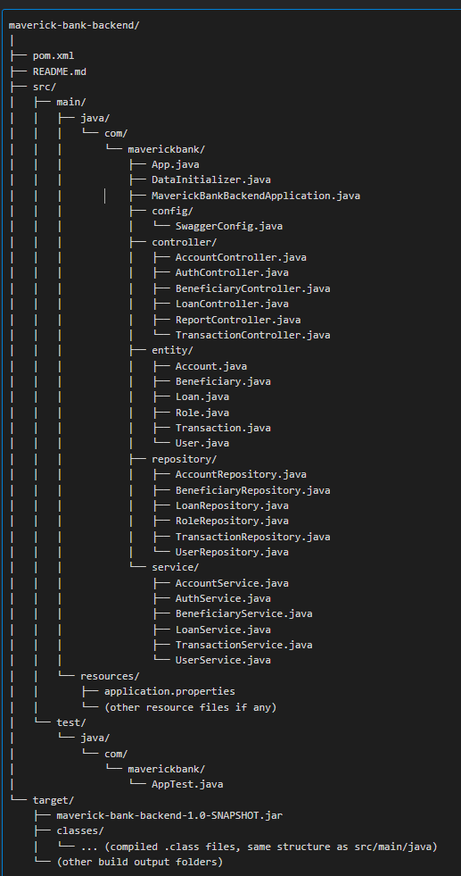

- `controller/` – REST controllers

- `service/` – Business logic

- `repository/` – JPA repositories

- `entity/` – JPA entities

- `config/` – Configuration classes

- **Naming Conventions**:

- Classes: PascalCase

- Variables/Methods: camelCase

- **Code Style**:

- Follow Java and Spring Boot best practices.

- Use meaningful commit messages.

Implementation and Output

**1:** [**auth-controller**](http://localhost:9090/swagger-ui/index.html#/auth-controller)

[**/api/auth/register**](http://localhost:9090/swagger-ui/index.html#/auth-controller/register)

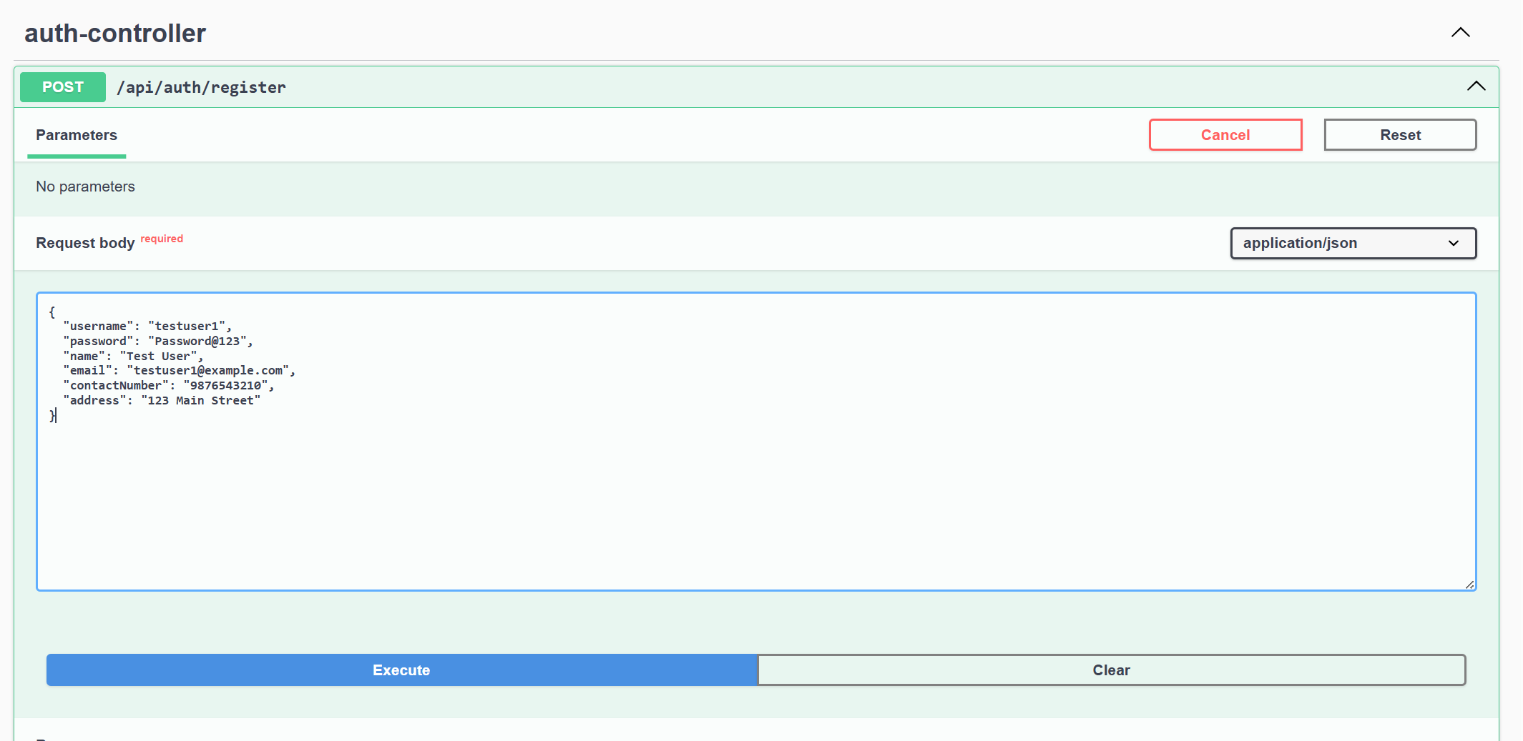

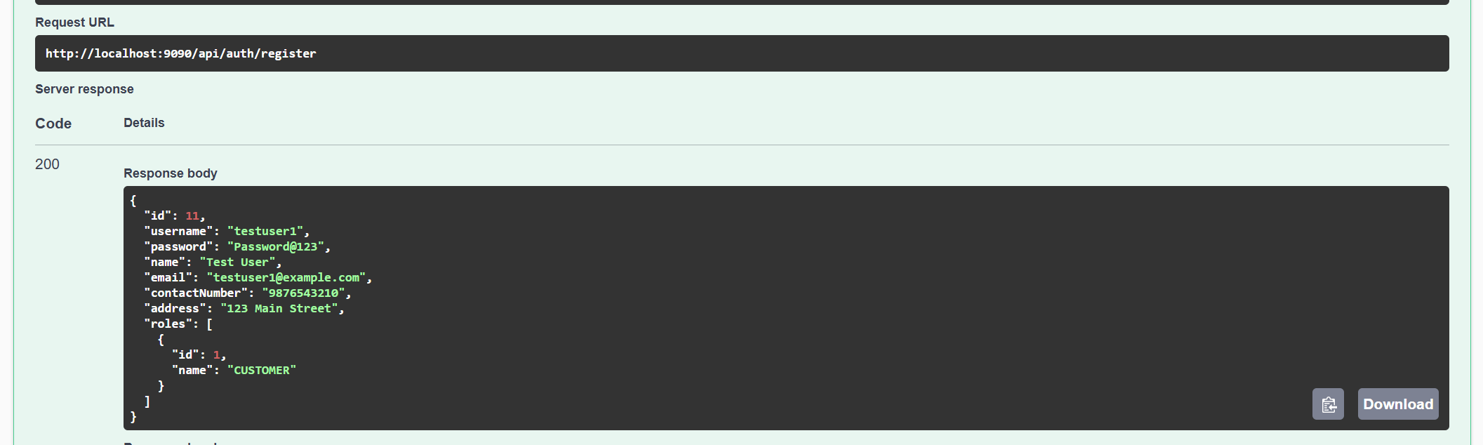

[**loan-controller**](http://localhost:9090/swagger-ui/index.html#/loan-controller)

[**/api/loans**](http://localhost:9090/swagger-ui/index.html#/loan-controller/applyLoan)

Apply for a loan

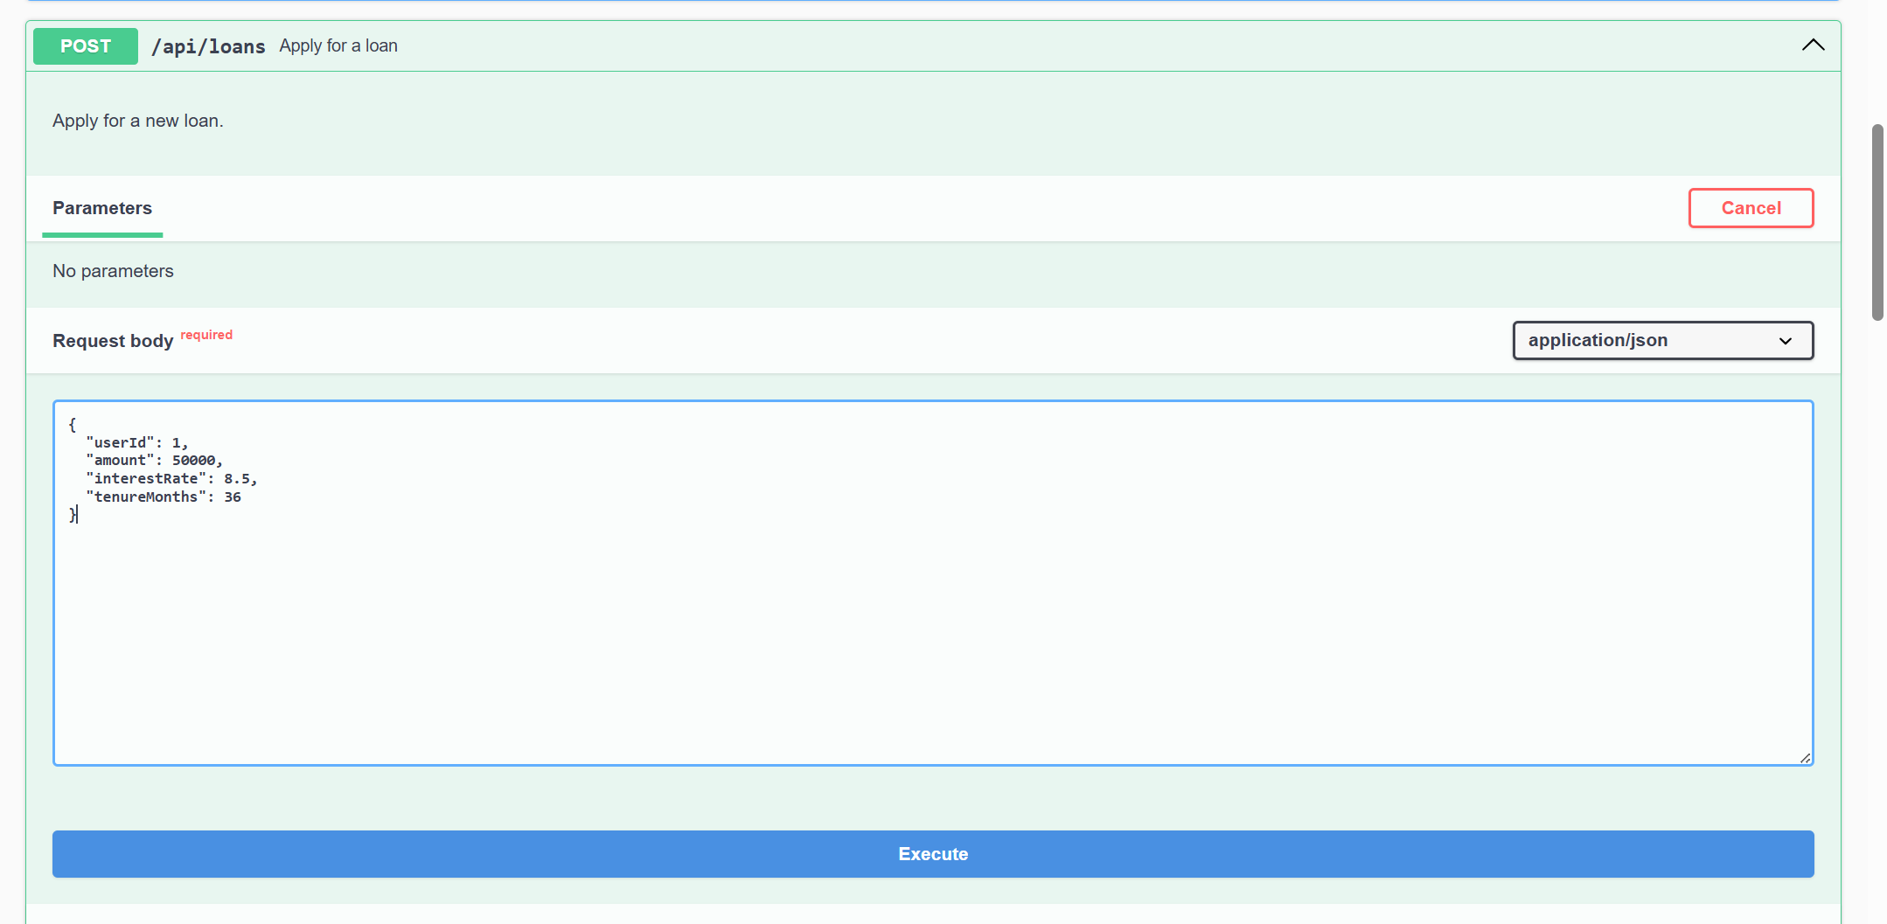

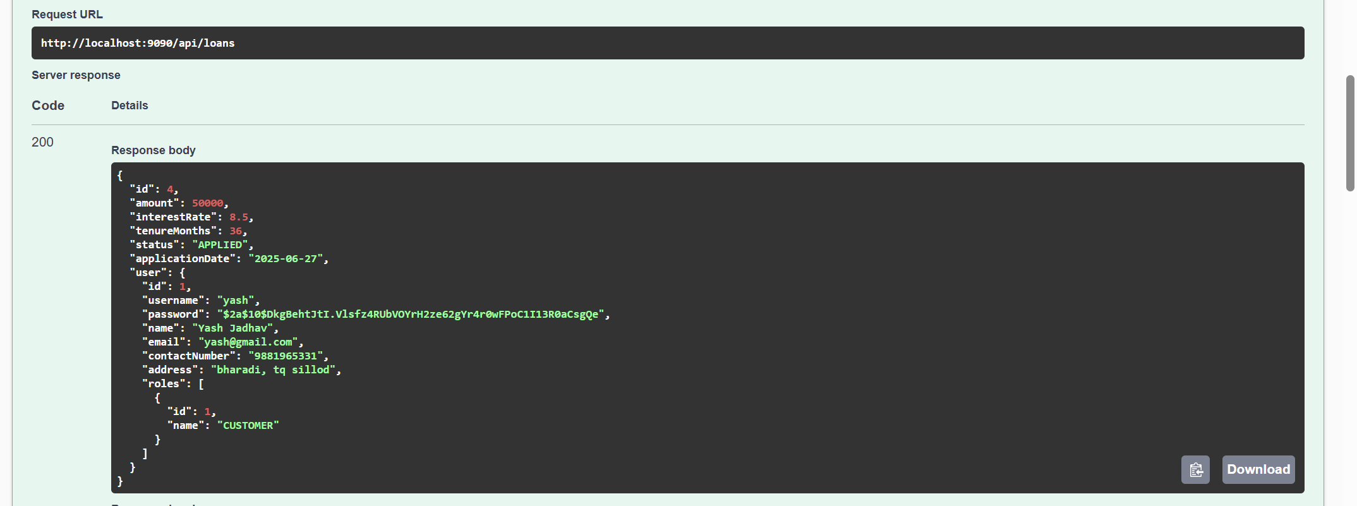

# [/api/loans](http://localhost:9090/swagger-ui/index.html#/loan-controller/getAllLoans_1)

Get all loans

# 

# [/api/loans/{loanId}](http://localhost:9090/swagger-ui/index.html#/loan-controller/getLoanById)

# Get loan by ID

# 

# [/api/loans/user/{userId}](http://localhost:9090/swagger-ui/index.html#/loan-controller/getLoansByUser)

# Get loans by user ID

# 

[**transaction-controller**](http://localhost:9090/swagger-ui/index.html#/transaction-controller)

[**/api/transactions/withdraw**](http://localhost:9090/swagger-ui/index.html#/transaction-controller/withdraw)

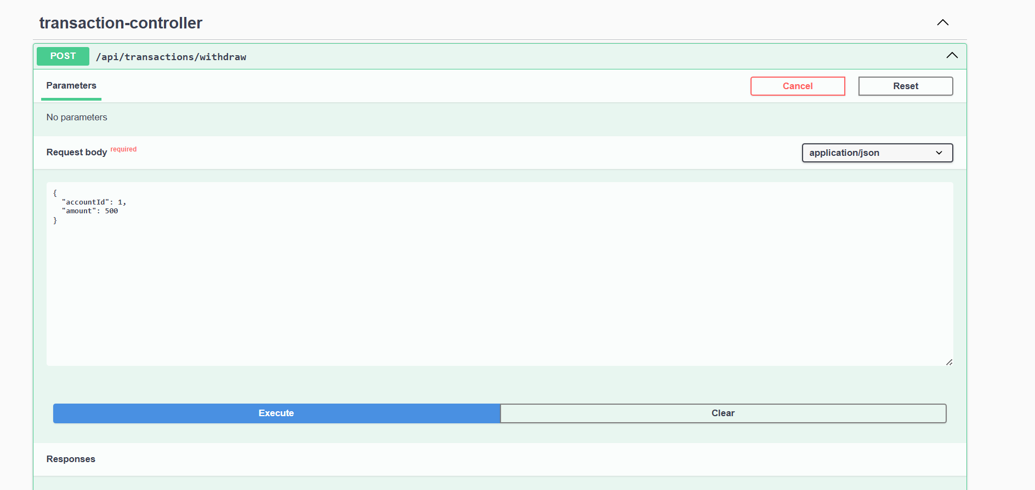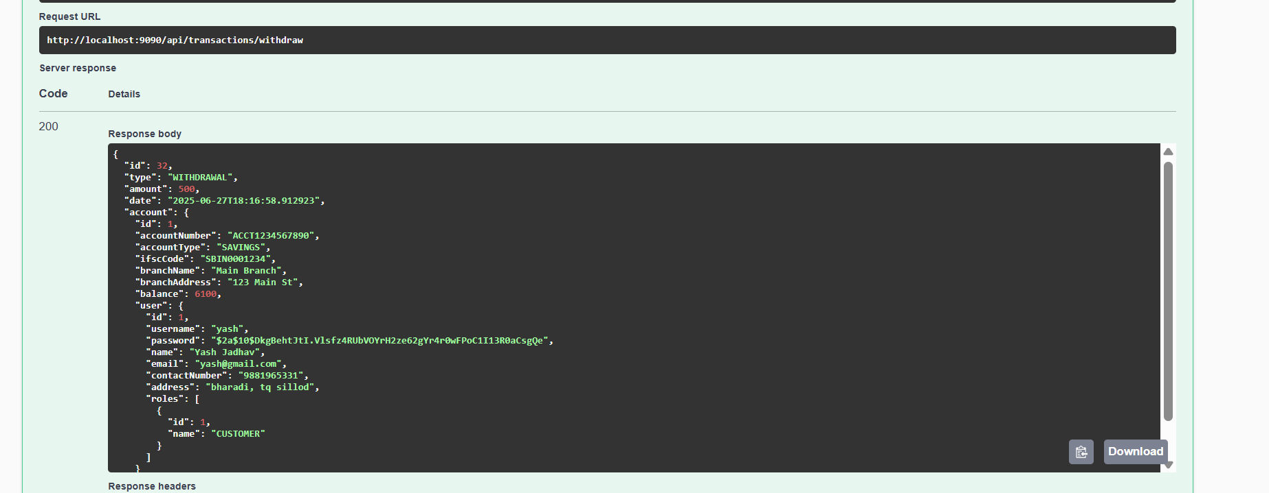

[**/api/transactions/transfer**](http://localhost:9090/swagger-ui/index.html#/transaction-controller/transfer)

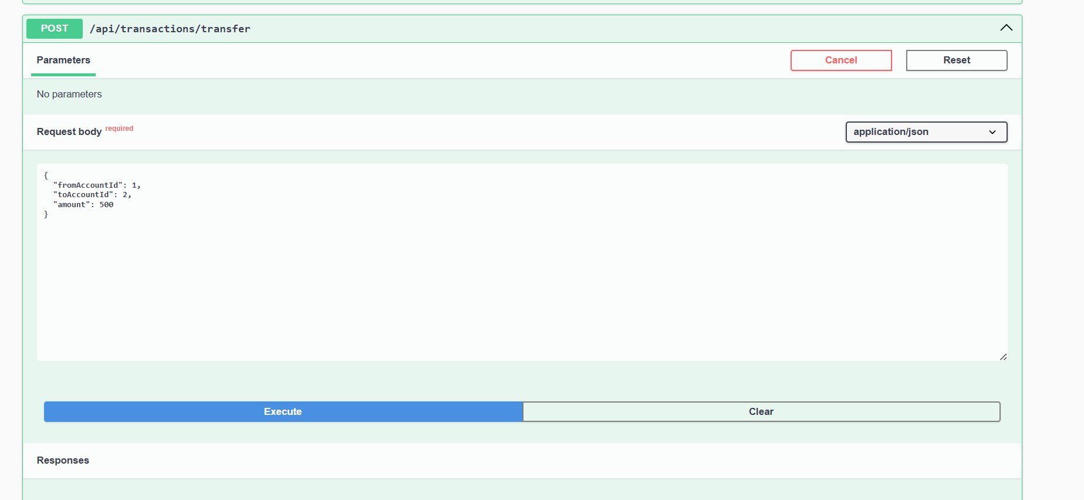

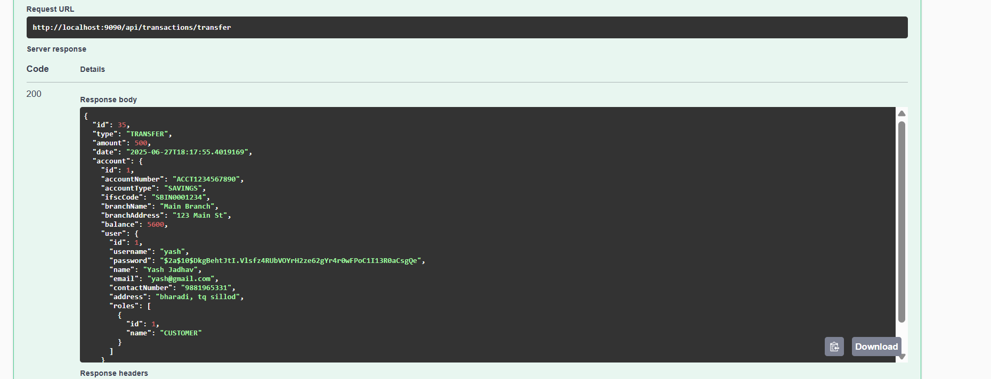

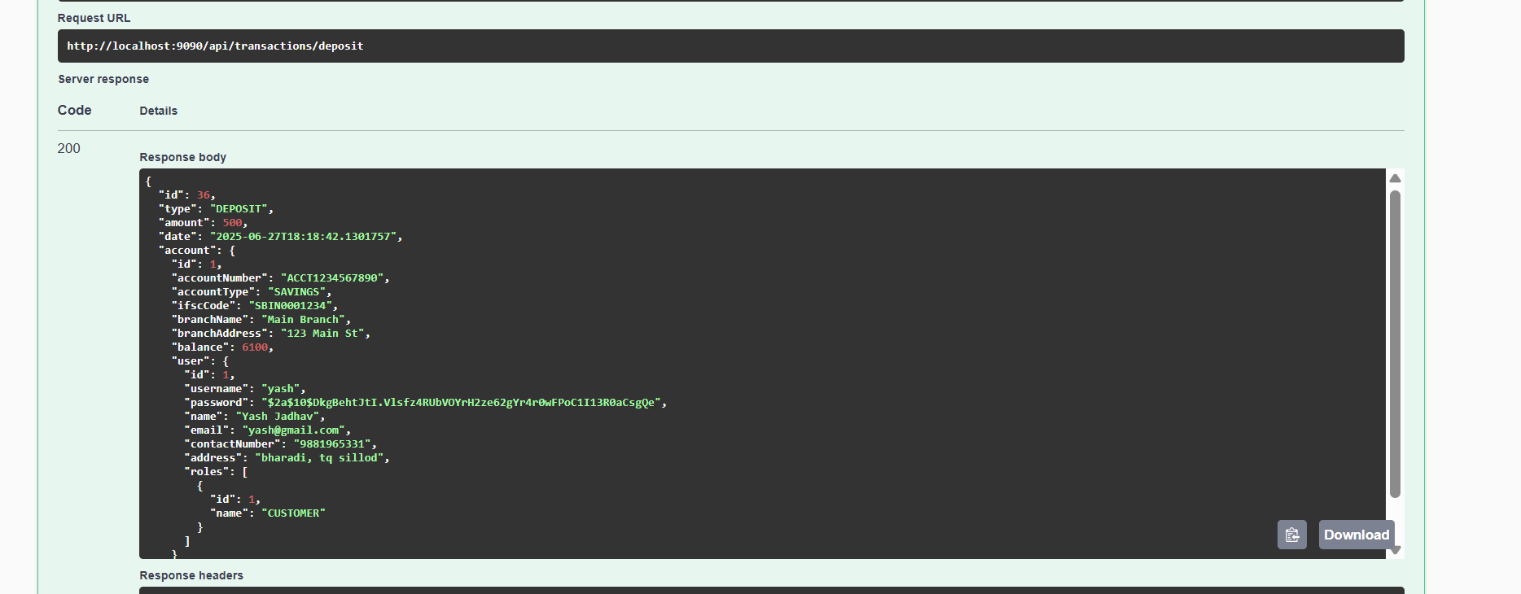[**/api/transactions/deposit**](http://localhost:9090/swagger-ui/index.html#/transaction-controller/deposit)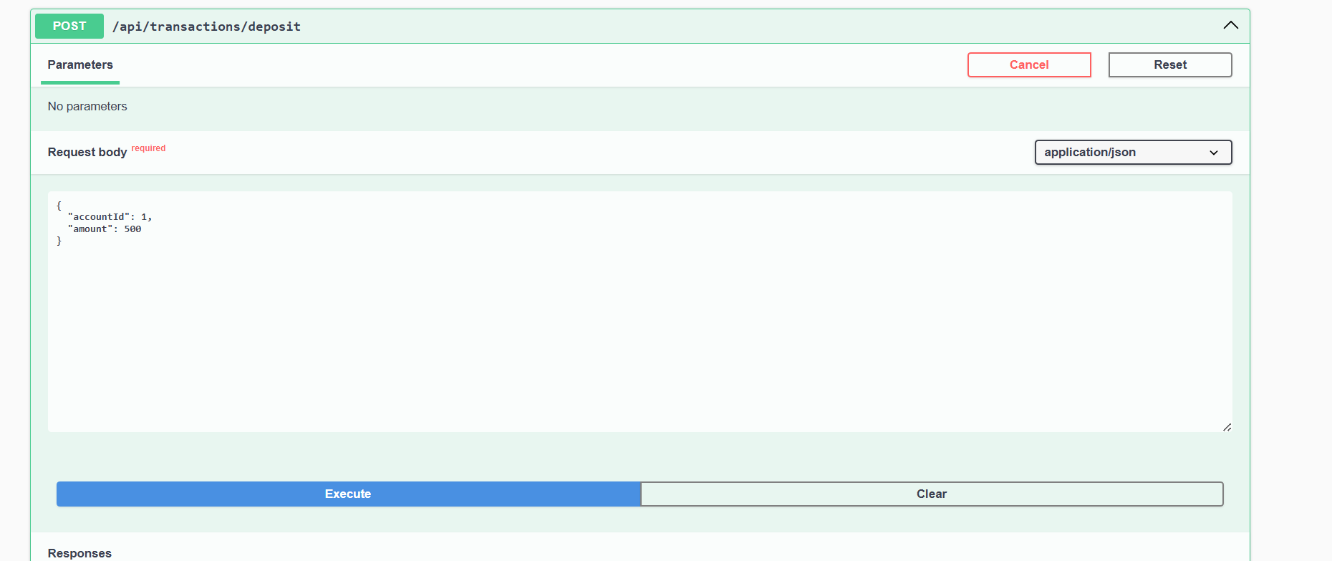**GET**

[**/api/transactions/account/{accountId}**](http://localhost:9090/swagger-ui/index.html#/transaction-controller/getTransactionsByAccount)

Get transactions by account ID

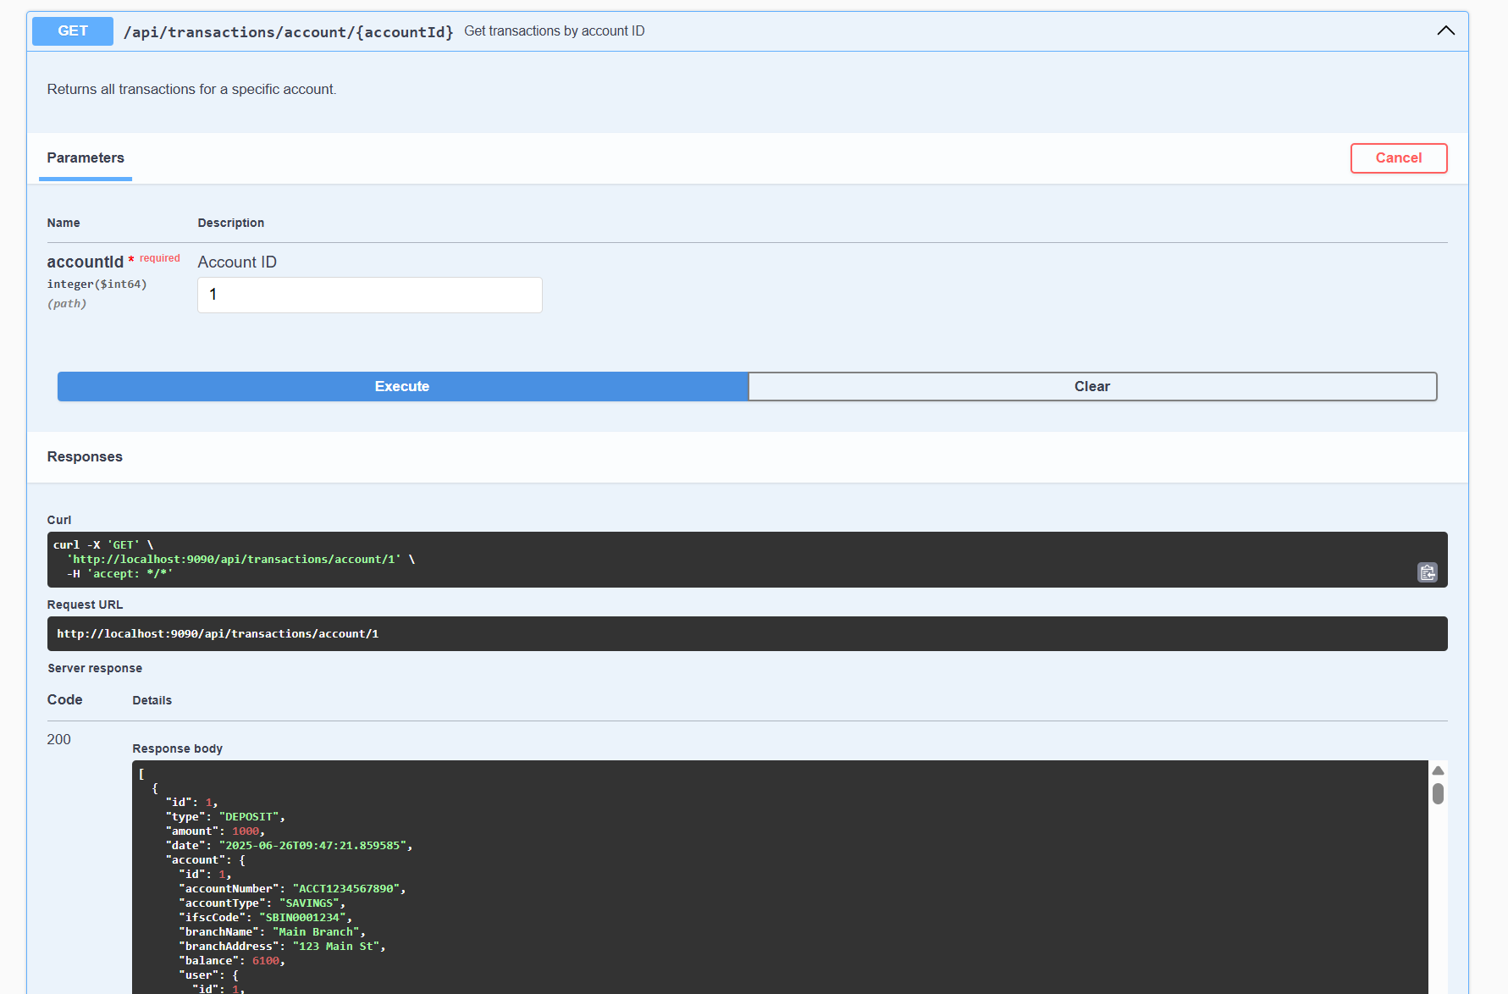

[**beneficiary-controller**](http://localhost:9090/swagger-ui/index.html#/beneficiary-controller)

[**/api/beneficiaries/user/{userId}**](http://localhost:9090/swagger-ui/index.html#/beneficiary-controller/getBeneficiariesByUser)

Get beneficiaries by user ID

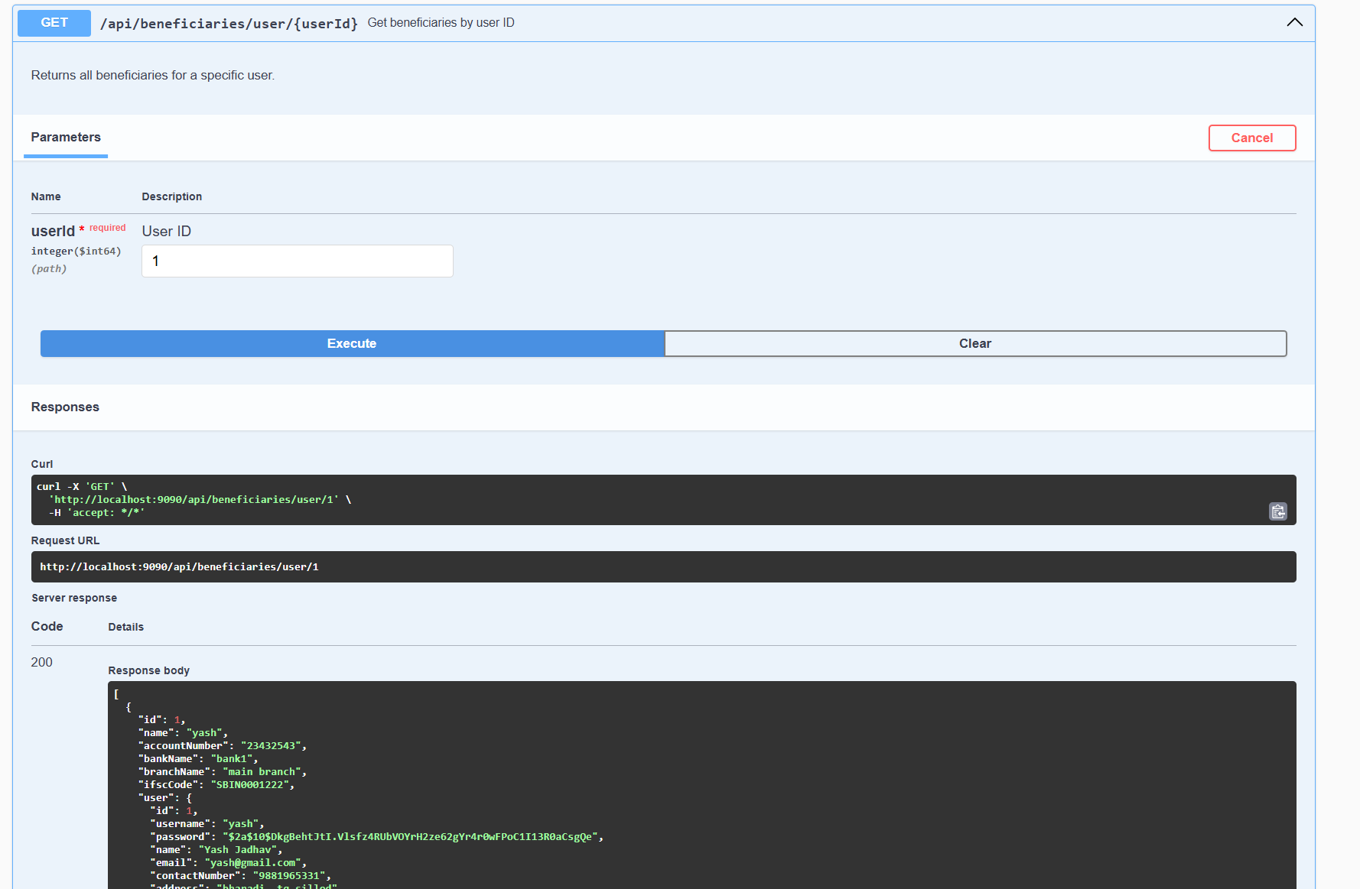

[**account-controller**](http://localhost:9090/swagger-ui/index.html#/account-controller)

[**/api/accounts/open**](http://localhost:9090/swagger-ui/index.html#/account-controller/openAccount)

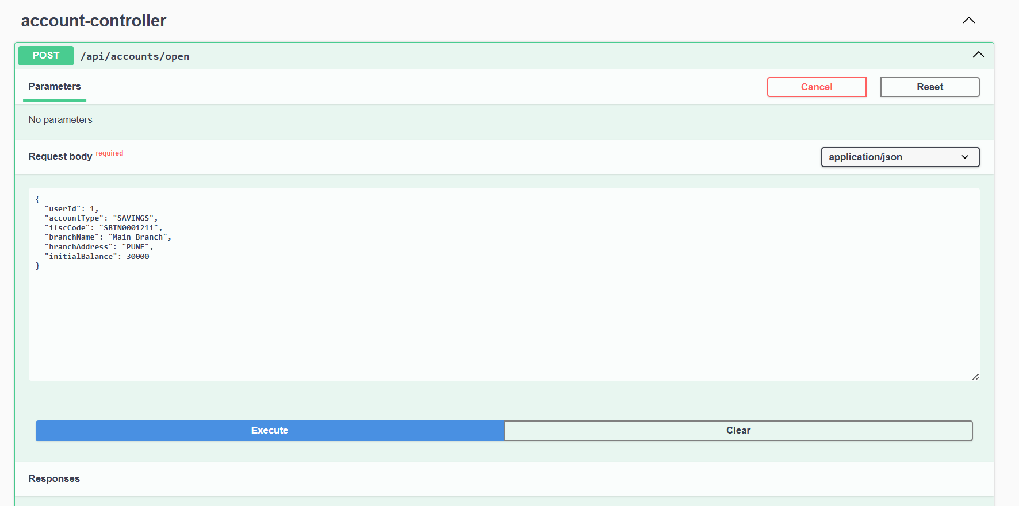  
  
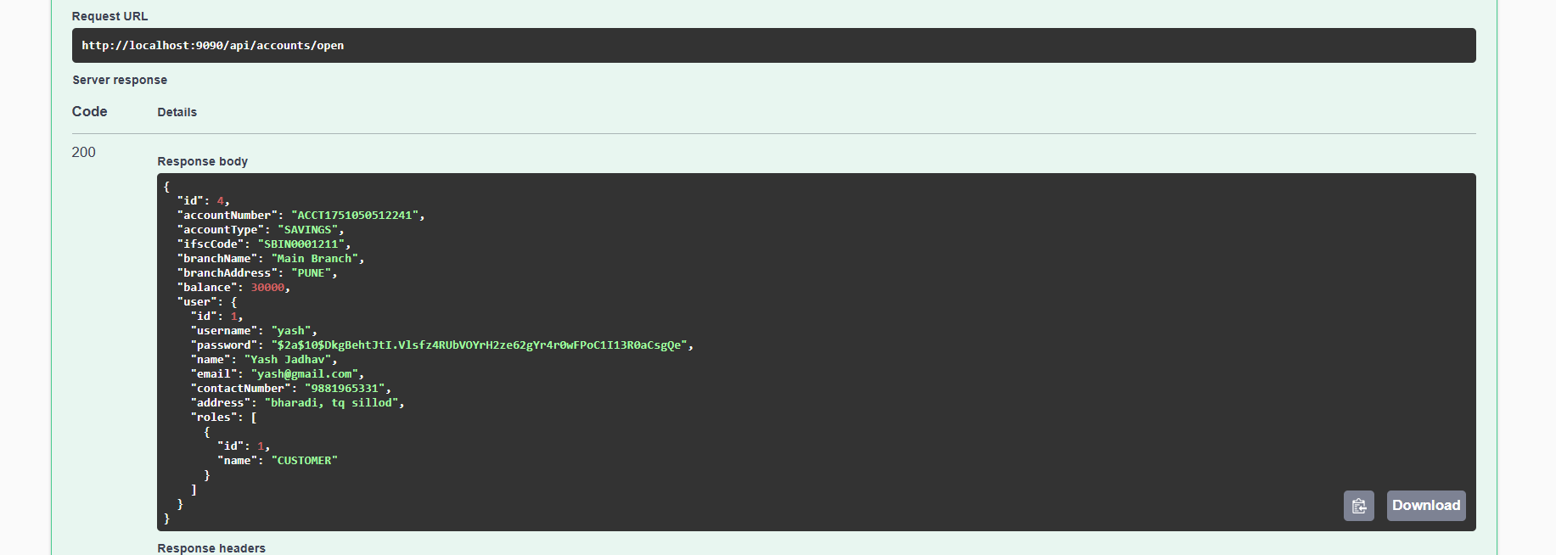

[**/api/accounts/{accountNumber}**](http://localhost:9090/swagger-ui/index.html#/account-controller/getAccountByNumber)

Get account by account number

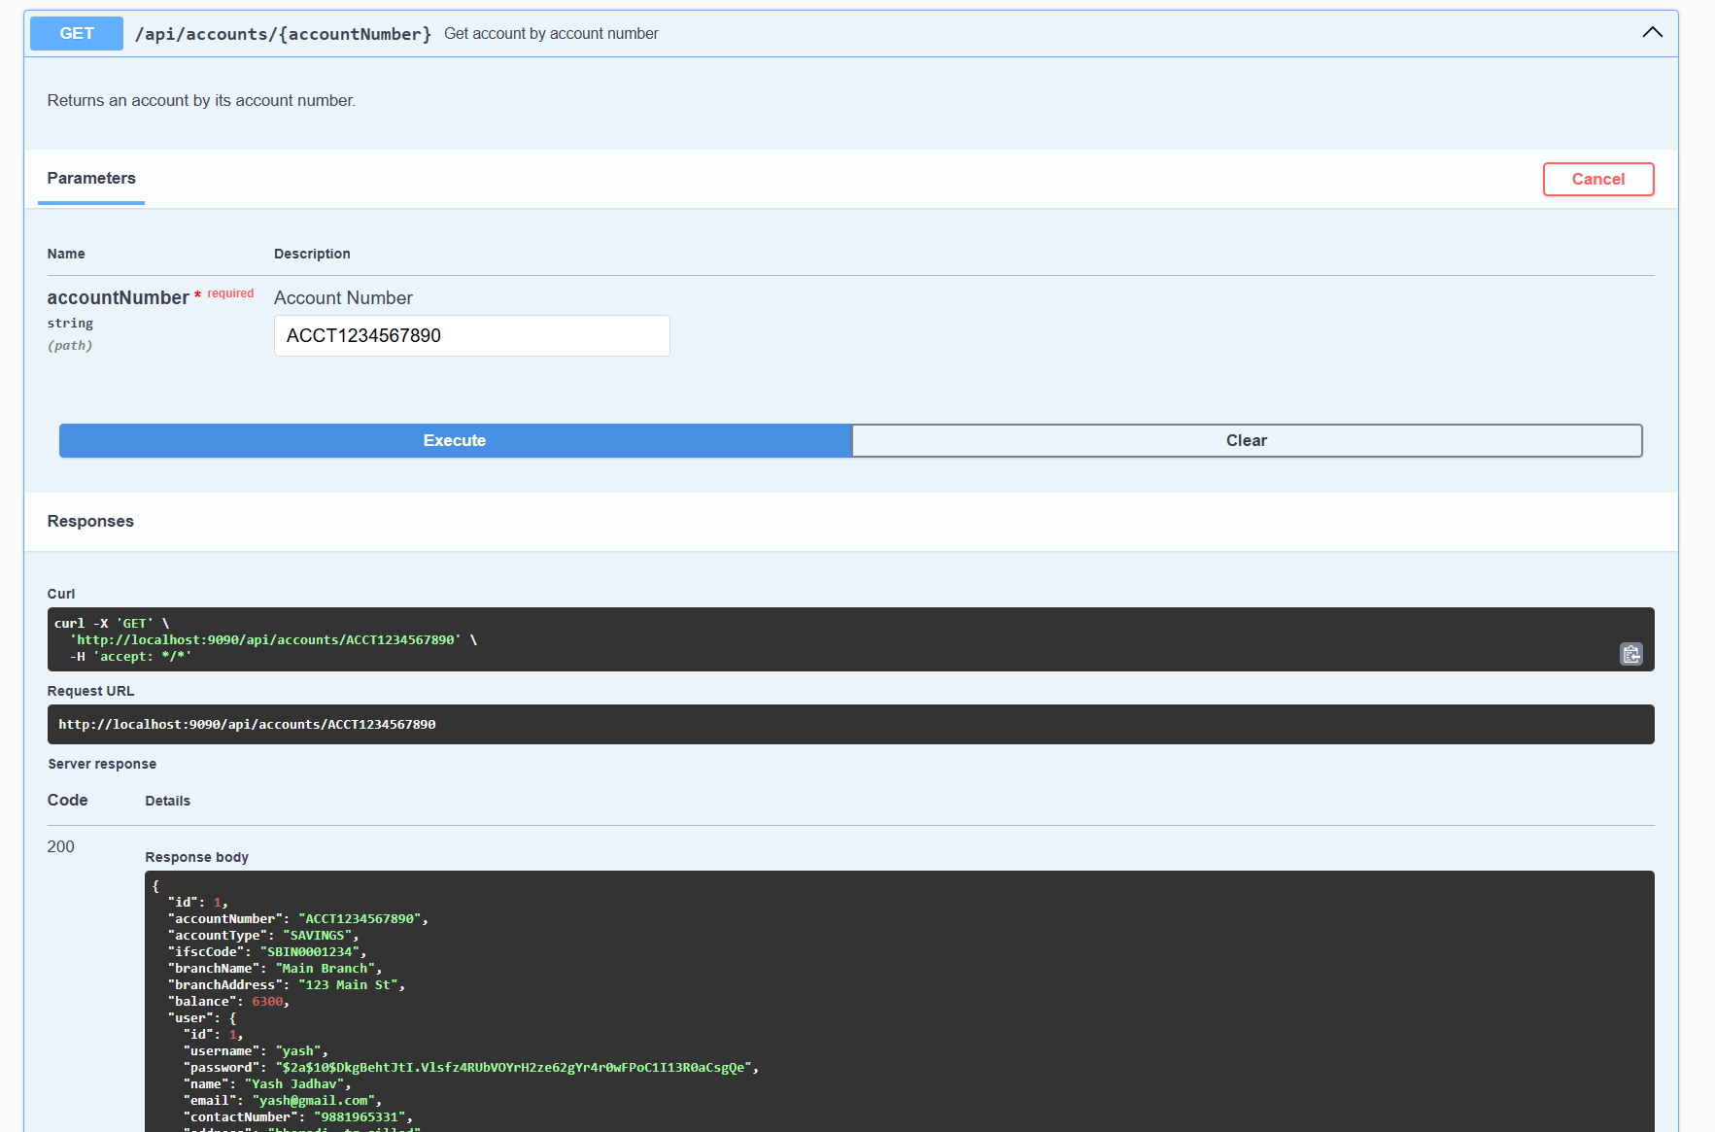

**GET**

[**/api/accounts/user/{userId}**](http://localhost:9090/swagger-ui/index.html#/account-controller/getAccountsByUser)

Get accounts by user ID

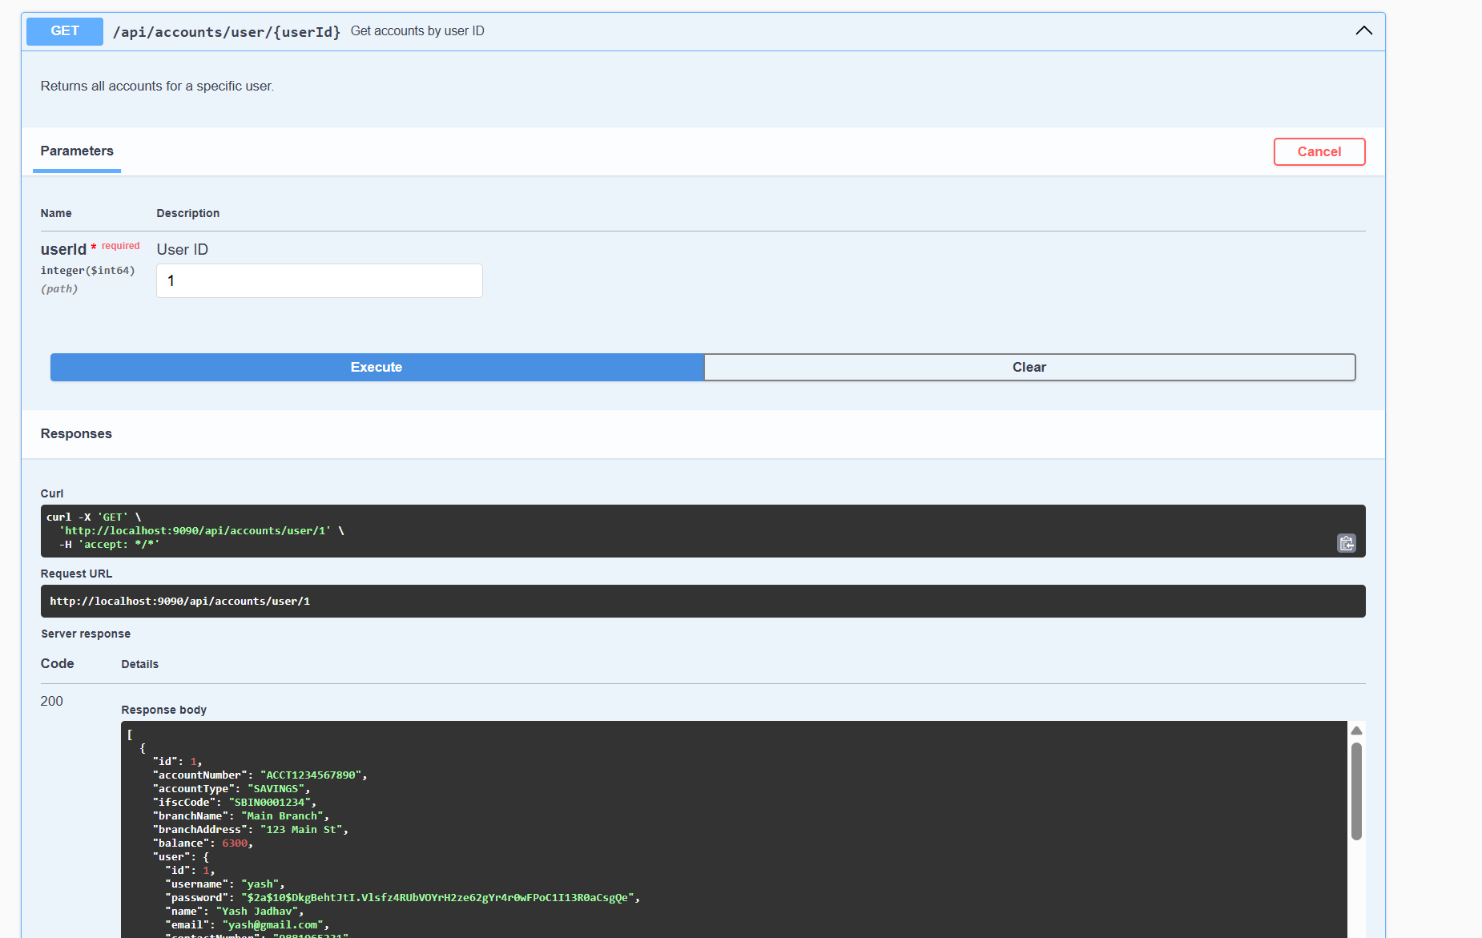

[**report-controller**](http://localhost:9090/swagger-ui/index.html#/report-controller)

[**/api/reports/transactions**](http://localhost:9090/swagger-ui/index.html#/report-controller/getAllTransactions)

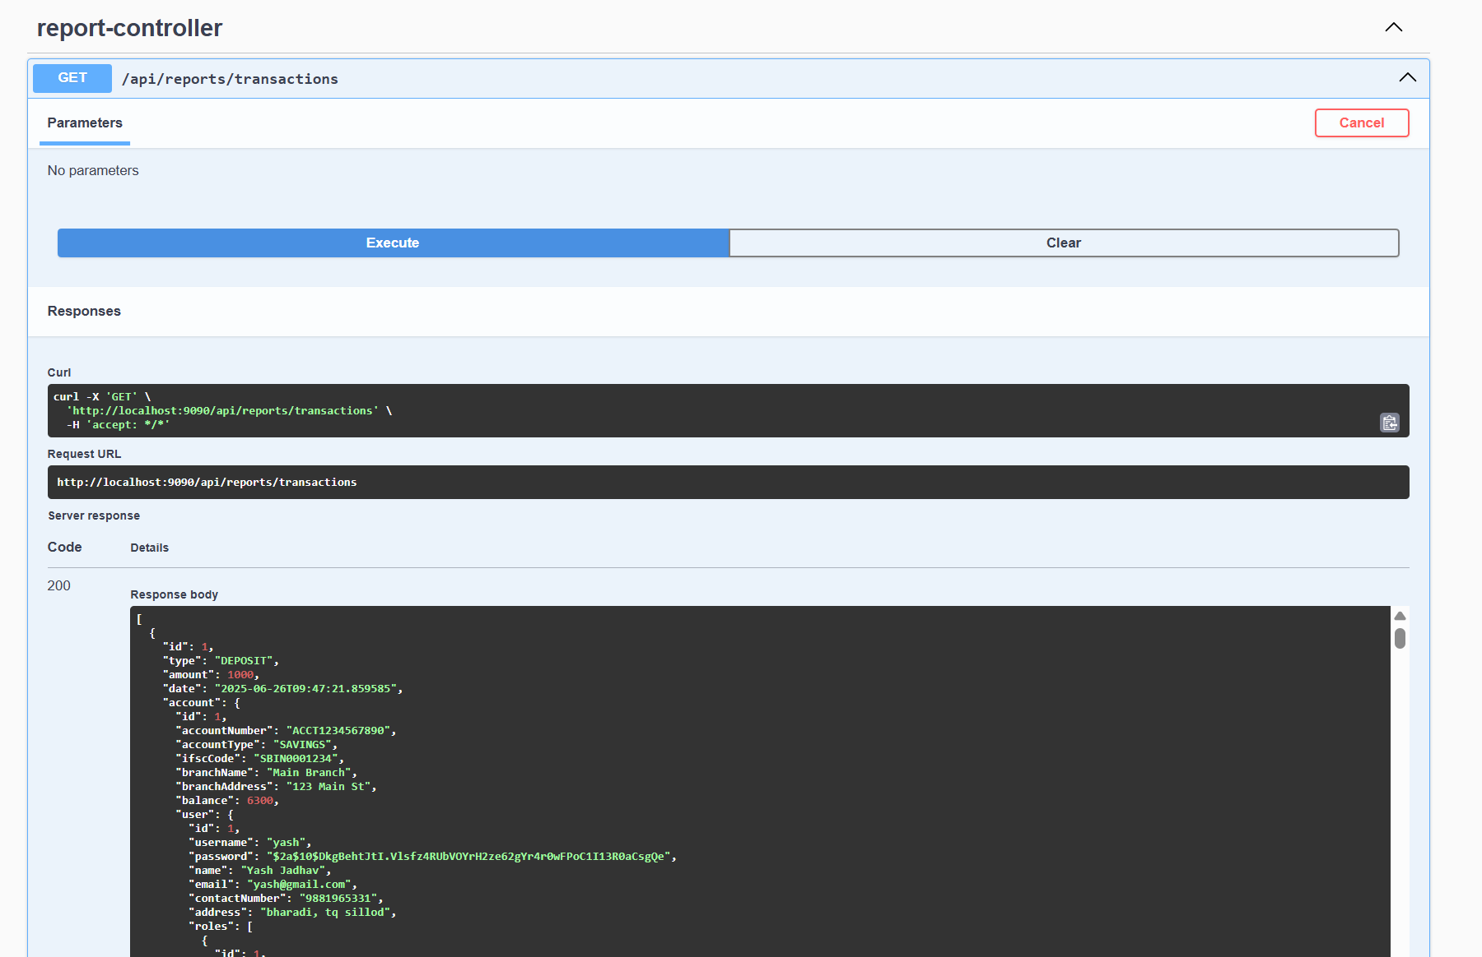

[**/api/reports/total-balance**](http://localhost:9090/swagger-ui/index.html#/report-controller/getTotalBalance)

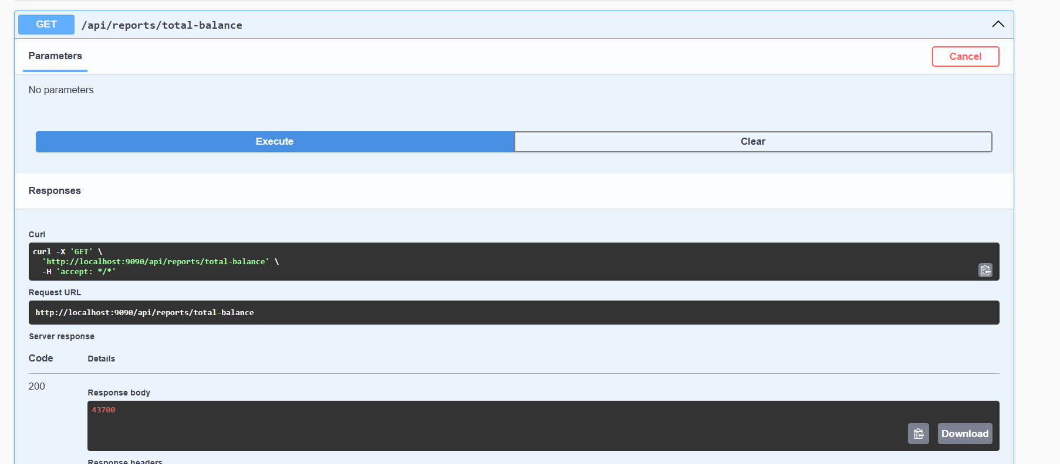

[**/api/reports/loans**](http://localhost:9090/swagger-ui/index.html#/report-controller/getAllLoans)

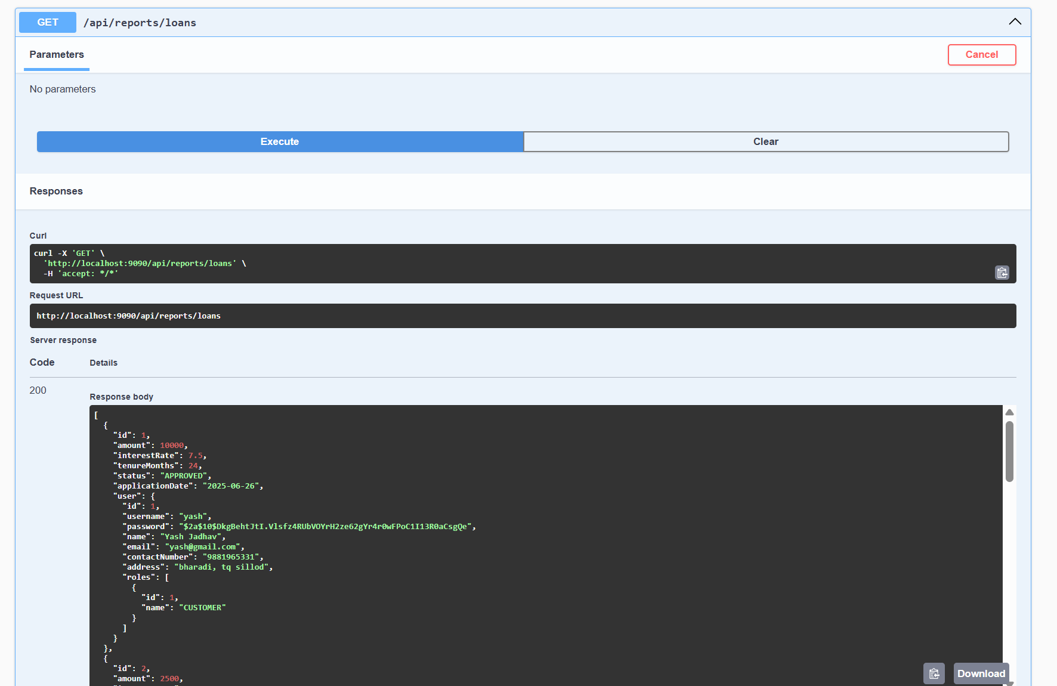

[**/api/reports/accounts**](http://localhost:9090/swagger-ui/index.html#/report-controller/getAllAccounts)

